# **Comparative analysis between SQL and NoSQL database and using appropriate database to create house rental management system**

A thesis submitted in part fulfilment of the degree of  
**BSc. (Hons.)BSc. (Hons.) in Computing**  
with the supervision of **Mr Manoj Shrestha**



**Submitted TO:**

Mr. Manoj Shrestha

Supervisor

**Submitted By:**

Netra Dahal

CU Id: 9636138

December, 2019

# **Declaration**

This thesis is a result of personal effort and completed all the requirement set by the university criteria and roles of similarity index. Contented of this thesis and project has not been used for any determination.

Netra Dahal

December 20, 2019

# **Abstract**

A greater part of undesirable issues looked via house owner and tenants appear to develop due to absence of communication. Late lease payment turns into a break a rent agreement. A non-useful Air conditioning or a broken window turns into motivation to break a rent agreement. Luckily, building a positive relationship doesn't require a lot of exertion and everything begins with one essential thought: communication. In a modern technology, there is a critical need to understanding and value the strength of innovation. Housing sector remains careful to confront the difficulties of progress by utilizing another system that encourages simple administration of house rental properties. Consequently there is have to build up an house rental property the board system that can separate work for the rental administrators with the goal that all their work can be effective and efficient.

House rental system application gives the arrangement by offering the capacity to share issues among tenants and house owner which prompts fast issue resolves and also, less misunderstanding. To get data about how house rental properties are presently being overseen, I arranged polls and submitted them to various house rental property supervisors and from the data I assembled I understood all work was done physically with a great deal of paper work included. Papers can without much of a stretch get harmed or get lost prompting loss of information. It is likewise costly to continue purchasing documents to store records. A great deal of records make a spot look confused and furthermore expend a great deal of room. Getting a specific document to check information from numerous records turns into a troublesome assignment. Thinking about those actualities, I chose to build up a house rental system property the board system that can challenge every one of the issues experienced with the present manual system. The system was created in such way that it gives most easy to understand interface.

When the user signs in the system naturally appear three structures: form, lease instalment form (payment form) and tenants‟, registration and login form. Each form has a few commands such as create, save, cancel, delete, next, previous and exit with the direction buttons. We can control the database. In the event that you need to include information to the database we should simply to tap on new at that point input information in the text boxes gave then quick additional and the information will logically be secure. In the event that we need to see information in the database, we simply click straightaway or previous and the information will be shown in screen. At the point when we click delete, this will have the option to delete a record that you want. We may enter information at that point choose to drop it, it is basic snap on drop and it will be dropped.

# **Keywords:**

**RDMS, NoSQL, ACID property, oracle, PHP, XAMPP, different between SQL, NoSQL, browsers**

# **Acknowledgment**

First of all, I would like to express my thanks to my supervisor Mr Manoj Shrestha for the continuous supports of my Bachelor’s degree, with his patience, motivation, enthusiasm and huge knowledge. I can’t imagine having a better supervisor than him to complete my degree. All thanks to his guidance that has helped me every time during my research and writing of thesis.

I would also like to thank for my parents for giving birth to me and support every moments of my life. In addition, I would like to thank my dear friends for supporting and standing beside me at hard times of life.

Netra Dahal

December 20, 2019

**Table of Contents**

**Comparative analysis between SQL and NoSQL database and using appropriate database to create house rental management system** 1

**Declaration** 2

**Abstract** 3

**Keywords:** 4

**Acknowledgment** 4

**Table of Figure** 8

**Thesis summary** 9

**I.** **Introduction** 10

**1.1 Background of Research** 10

**1.2 Problem Statement** 11

**1.3 Research Question** 11

**1.4 Project Scope** 11

**1.5 Aim** 11

**1.6 Objectives** 11

**1.6 Project Deliverables** 12

**1.7 Ethical Consideration** 12

**1.7.1 Ethical Issue** 12

**II Literature Review** 13

**2.1 Introduction** 13

**2.1.1 Types of Database** 13

**2.1.1.1 Centralize database:** 13

**2.1.2Distributed database:** 14

**2.1.3 Personal database:** 15

**2.1.4 End-user database:** 15

**2.1.5 Commercial database:** 15

**2.1.6 NoSQL database:** 15

**2.1.7 Operational database:** 16

**2.1.8 Relational database (SQL Database):** 16

**2.1.9 Cloud database:** 17

**2.1.10 Object-oriented database:** 17

**2.1.11 Graph database:** 18

**2.2 Secondary Research** 19

**2.2.1 Features of NoSQL database** 19

**2.2.2 Features of SQL database** 19

**2.3 SQL and NoSQL database Migration process** 20

**2.3.1 Different between NoSQL and SQL Database** 21

**2.5 Disadvantage of NoSQL Database** 21

**2.6 Disadvantage of SQL Database** 21

**2.7. Conclusion** 21

**III Methodology** 22

**3.1 Introduction** 22

**3.2 Fact finding methods** 22

**3.2.1 Objectives** 22

**3.2.2 Questionnaires** 22

**3.2.3 Secondary data collections** 22

**3.3 System Development Methodology** 22

**3.3.1 Waterfall Model** 22

**3.3.3.1 Feasibility study** 23

**3.3.3.2 Requirement Analysis** 23

**3.3.3.3 System design** 23

**3.3.3.4 Implementation or coding** 23

**3.3.3.5 Testing** 23

**3.3.3.6 System deployment and maintenance** 24

**IV. System analysis and requirement Modelling** 25

**4.1 Introduction** 25

**4.2 Existing System** 25

**4.3 Problem of existing system** 25

**4.4 Requirement Analysis** 25

**4.4.1 User Requirements** 26

**4.4.2 Functional requirements** 26

**4.4.3 Hardware Requirement** 26

**4.4.4 Software Requirement** 26

**V.** **House Rental System application: Tools and technology** 27

**5.1 Github:** 27

**5.2 PHP:** 28

**5.3 MySQL Database:** 29

**5.3.1 Advantage of MySQL** 29

**5.3.1 Operating system of MySQL** 29

**5.4 Apache web Server** 29

**5.5 XAMPP** 29

**5.5.1 Functionality of XAMPP** 30

**5.5.2 Installing process of XAMPP** 30

**5.6 PhpMyAdmin** 31

**5.7 Er Diagram:** 31

**5.8 Photoshop:** 31

**5.9 HTML** 32

**5.10 CSS** 33

**5.10.1 Advantage of CSS** 34

**5.11 JavaScript** 34

**5.11.1 Uses of JavaScript** 35

**5.12 Technical Specifications** 36

**5.12.1 Usability** 36

**5.12.2 Availability** 36

**5.12.3 Scalability** 36

**5.12.4 Performance** 36

**5.12.5 Reliability** 36

**5.12.6 Security** 36

**5.12.6 Version control** 36

**VI. Project Plan** 37

**VII. System Design** 40

**7.1 Design Phase** 40

**7.1.1 Conceptual Design** 40

**7.1.2 Database Design** 40

**7.2 Software Interface** 41

**VIII. System Implementation and testing** 45

**8.1 System Implementation** 45

**8.1.1 End user Training** 45

**8.1.2 End User education** 45

**8.1.3 Training in the application software** 45

**8.1.4 Post implementation Review** 45

**8.2 System Testing** 45

**8.2.1 Black Box Testing** 45

**8.2.2 White box testing** 46

**IX. Recommendation, future work and Conclusion** 47

**9.1 Recommendation** 47

**9.2 Conclusion** 47

**9.2.1 Summery of SQL and NoSQL Database** 47

**9.2.2 Summery of Product (House Rental System)** 47

**9.2.3 Personal Reflection** 47

**9.3 Future Work** 48

**10 Bibliography** 49

**Appendix** 51

**SWOT Analysis** 51

**Installation Process** 51

**XAMPP Install process** 51

# **Table of Figure**

Figure 1 centralized database 13

Figure 2 distributed Database 14

Figure 3 personal Database 14

Figure 4 End User Database 15

Figure 5 NoSQL Database 15

Figure 6 Operational Database 16

Figure 7 Relational Database 16

Figure 8 Cloud Database (Wadhwa, n.d.) 17

Figure 9 Object oriented database 17

Figure 10 Graph Database (Clarke, n.d.) 18

Figure 11 SQL vs. NoSQL (Odendaal, 2018) 20

Figure 12 Waterfall Model 23

Figure 13 Requirement Analysis 26

Figure 14 Software tools 27

Figure 15 github logo 28

Figure 16 PHP syntax: connections to MySQL database 28

Figure 17 XAMPP control panel 30

Figure 18 logo of Photoshop 32

Figure 19 HTML Format 33

Figure 20 CSS of house Rental system 33

Figure 21 rent.js in house rental system 35

Figure 22 Gantt chart 37

Figure 23 List of working flow with date 39

Figure 24 Login page 41

Figure 25 Register page 42

Figure 26 Admin Dashboard 42

Figure 27 Home page 43

Figure 28 Search 43

Figure 29 Room Register 44

Figure 30 Update table 44

Figure 31 complaint list 44

Figure 32 SWOT Analysis 51

Figure 33 Tree view of admin 1 57

Figure 34 Tree View of admin 58

Figure 35 Admin Dashboard 58

Figure 36 Database connection 59

Figure 37 Header 59

# **Thesis summary**

Brief overviews of this document are as given below:

Chapter 1: in this chapter contains the descriptions, definitions, ethical considerations, project aims and objectives.

Chapter 2: In this chapter contains literature review of the SQL and NoSQL database. This chapter also describe about data migrations in relational and non-relational database, different between SQL and NoSQL database.

Chapter 3: in this chapter, describe about system development methodology and collection of data collections.

Chapter 4:  in this chapter contains system analysis and requirement modelling. Inside this chapter, describe about existing system, their problem and their requirement analysis.

Chapter 5: In this chapter contains tools and technology which is necessary for the development of web applications such as house rental system. Tools and technology contains Github, Apache server, XAMPP, PhpMyAdmin, MySQL, PHP, HTML, CSS, JavaScript’s etc.

Chapter 6: In this chapter contain project plan of the system. Gantt chat of project plan and list of working flow of data.

Chapter 7: In this chapter contains system design of the system. It include conceptual diagram, database design and software interface.

Chapter 8: In this chapter contains system implementations and testing of the house rental system. This include training about new system, system educations, implementations reviews and discus about different types of testing such as black box testing, white box testing.

Chapter 9: In this chapter contains recommendations, future work and conclusions of the project

Chapter 10: in this chapter contains overviews of bibliography or reference of project.

# **Introduction**

In this thesis, two database are compare and analysis that is Relational database (SQL Database) and NoSQL Database (non-relational database). Now a day one application support millions or billions of users at a one time and control as well as handle large volume of data. Database is a system which is control large amount of data at a one time. Database are mainly two type’s i.e. relational database (SQL) and Non-relational database (NoSQL). Relational database model has most complicated when control and handle of large amount of data. So, control of this limitation to the development of non-relational database. In this thesis, we are comparing the both SQL and NoSQL database. In the final which database is suitable for development of house rental management? House is an essential parts of human being. So, Analysis of this importance to proposed of house rental system which is an essential factor in current or modern society. Hence, this thesis provides brief knowledge of background study of rental system, problem statement, project scope, objectives, project risk, justification and total budget and time. I have compare SQL and NoSQL database which one is suitable I will make web application name as house rental management system.

A house rental system is a house that can be used temporarily for a period of time with a fee or charge. Renting a house assists people to live in a comfortable house when they do not have access to build their own personal house. The individual who want to rent a house or room first contact the house owner for the desire house. This can be done online. At this time, this tenants has to supply some information such as type of house or room or flat, total cost or rental amount etc... After these details are workout, the individual renting the house must present a valid identification card

## **1.1 Background of Research**

Day by day it is seen in a few different ways that the data improvement has entered into different aspects of our lives and has encouraged it. In view of the mechanical improvement in the field of Personal computer system and the establishment of huge broadcast communications arranges, the administration, the handling and the scattering of data turns out to be increasingly effective, and thusly it is improving the exercises which are related with this data. In this way, an ever increasing number of emergency find out home, room and flat worldwide have to a great extent executed Integrated Information Systems so as to cover the administration required for the managerial, house rental system.

A house is an essential and residence-place used as a permanent or semi-permanent residence for a human being. We charge a room in our house that is always existing for short term occupancy by paying customers. Home is a one of the must need of human being. If any people who have no home may stay through paying rent for other people who have more houses or more room in one house. In our environment there are many rented house and renter. All renter has different type of behaviour that show different character on rented people. Some renter has shown bad behaviour and some people show positive relationship on house owner or other tenants’ people. Renting system of home may contain advantage and disadvantage.

Some advantage of home renting system is:

* Lower housing costs for tenants.
* Income sources for house owner.
* Short term commitment
* No minimal repair costs and maintenance

Some disadvantage of house rental system is:

* No tax incentives
* No fixed room/housing costs
* Interior design may contain only owner concept.

## **1.2 Problem Statement**

In a system are divided into two sector one is SQL storage and other is NoSQL storage create a gap between two database in the term of constant data access. In this time, there is no solution are available to fulfil the gap between two database.

In a Nepal, room rent is a main irritation for people. Mainly, people have many priority based on their house rent. In modern time all people want to rent their house/ room in online system. To notified this situation and minimize of irritation free situation, a dynamic system can be developed. This system helps to tenants for find out used full house without any irritation. Some problem of recent system are:

* Not communication between tenants and house owners.
* Paper based payment system.
* If any problem or meeting, owners physically meet tenants
* Time constrain
* Waiting of owner for the end of month.
* Waiting of tenants for the payment.

## **1.3 Research Question**

Comparison between SQL and NoSQL databases and how is SQL better than none SQL database? What kind of database should be used for building suitable system?

## **1.4 Project Scope**

It is defined as the descriptions of system work which is required in delivering the house rental system. The main scope of this research are given below:

* Research and understanding of the system project.
* Developed software requirement specification of system project.
* Develop software design
* Develop software design and implementation documentation.
* Research about SQL and NoSQL database to find out which is suitable for house rental system

## **1.5 Aim**

Comparative analysis between SQL and NoSQL database and using appropriate database to create house rental management system

## **1.6 Objectives**

* Demonstrate how to used SQL and NoSQL database to store and save insistent data.
* Compare different type of data in both database and find out which is suitable for developing house rental system.
* Try to develop an efficient applications that will be also helpful for house rental.
* Study of current available open source applications developed in other city or country
* Analysis the applications and try to modify them according to Nepal environment.
* Demonstrate how to used PHP and JavaScript to create dynamic web applications.
* Modified and store House rental system data in SQL database
* To produce the documentation such as Software Requirement specification, Software Design Description and Software Development References

## **1.6 Project Deliverables**

The fundamental deliverable of this system and thesis will be the finished house rental system and the thesis completed report that include:

* Software requirement and specification
* Software design document
* Create software engineering and its documentations

## **1.7 Ethical Consideration**

At the point when I started my work on the proposal I was constantly focus around my research. In any case, when I started to clear my path through research, I understood that research ethics a centre part of the research work and the establishment of research plan.

### **1.7.1 Ethical Issue**

Ethical issue is a main problem in the any type of research field. We are understood about ethics of research so that our thesis should not harm any person, religion, society directly or indirectly while achievement of research.

Some ethical consideration of research about SQL and NoSQL database to developed house rental web application are given below:

**Harmful work:** in the time of research, collected data cannot be used for criminal purpose or harmful activities that is harm the social life of common people.

**Confidentiality:** the information of participant, questions and their answer must be kept in confidential. Only research related information display in documentation.

**Validity:** The research configuration must address clear research questions. Successively, the summery of the study must correspond to the inquiries presented and the outcomes. Likewise, inquire about morals requests that the techniques utilized must relate clearly to the research questions. (enago academy, 2019)

**Research Method:** We know there are various research strategies. On the other hand, with regards to ethical consideration, some key inquiries can assist us with finding the correct methodology for our research (enago academy, 2019). Some example are:

What is the strength and restrictions of using methodology?

Which method is best and effectively fit the aim of house rental system?

# **II Literature Review**

## **2.1 Introduction**

Thesis written by someone to consider the main points of current knowledge added substantive search as well as academic and working contribution to a particular topic are called as literature review. Main goals of literature reviews are known as situate the current study within the body of works and provides framework for the specific reader.

A variety of published and unpublished literatures produced by various government and non-government organizations and agencies were reviewed during the study period. Some of the major categories of the reviewed works were as follow;

According to Aquino (2005), important of computer are application are growths day to day. In the current times of the time winning organization are those which are ready to integrate business strategy and CIT results for them to be able to development of software efficient, reliable and secure. In a Nepal many places include computerize system such as school management system, hotel management system, rental system etc.

Database is a systematized collection of structured information or data, typically stored electronically in a computer system. Database is usually controlled by a database management system (DBMS).

## **2.1.1 Types of Database**

Depending upon the usage requirements there are following type of databases available in the market:

### **2.1.1.1 Centralize database:**

The information (data) stored at a centralize server and many users from different area can access centralized server data. This type of database contains application procedures. For example:

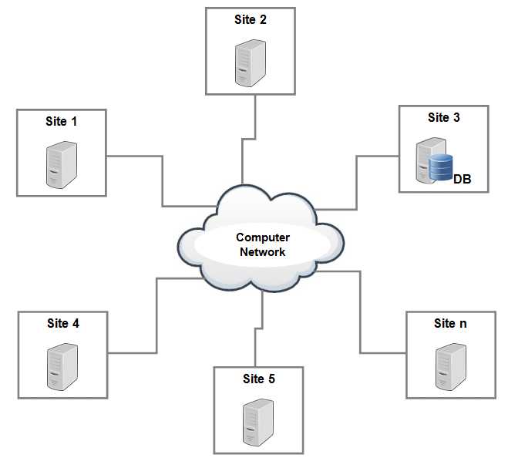

Figure 1 centralized database

### **2.1.2Distributed database:**

This database is an opposite of centralized database concept because it has contribution from common database as well as information released by local computer. In this system data are not located one place or server and it issues at different sites at an organization. For example:

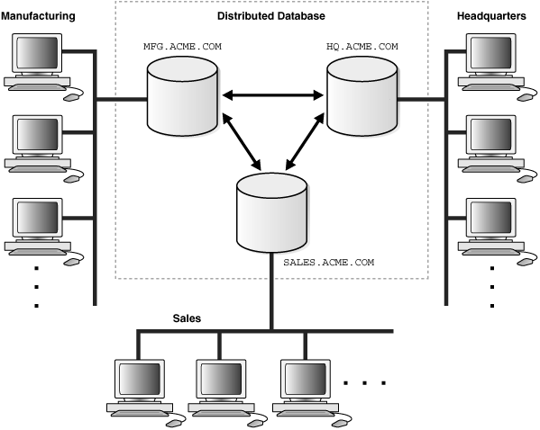

Figure 2 distributed Database

### **2.1.3 Personal database:**

This is small and easily manageable database because data are collected, store and manipulate on personal computer. This type of database accessed by small group of people. For example: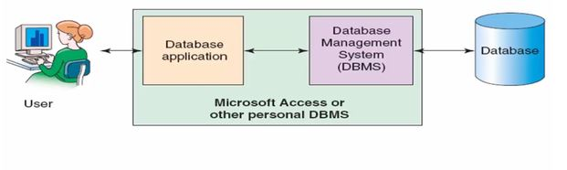

Figure 3 personal Database

### **2.1.4 End-user database:**

This type of database are also known as shared database because it is mainly designed for end user and whole information collected in this database. For example

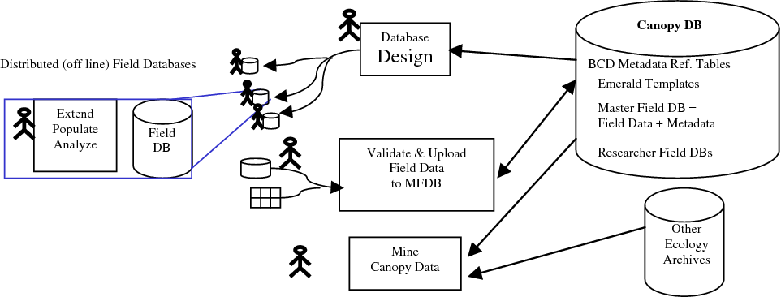

Figure 4 End User Database

### **2.1.5 Commercial database:**

It is paid version of the huge databases planned individually for the users who wants to access the information. This is subject specific and one person cannot maintain available huge (many more) information.

### **2.1.6 NoSQL database:**

This database covers a wide change of different database technologies that developed massive volumes of new, frequently changing data types, data structure and polymorphic data. This type of database mainly used in large sets of distributed data. This database easily and effectively handled big data performance issues and mainly used in analysis of large amount of unstructured data. Mongo DB is the best example of NoSQL database.

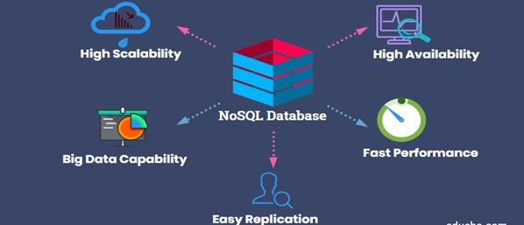

Figure 5 NoSQL Database

### **2.1.7 Operational database:**

The information stored inside the database are related to operations of an organization.

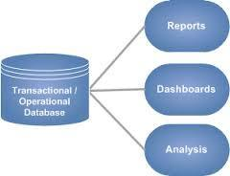

Figure 6 Operational Database

### **2.1.8 Relational database (SQL Database):**

It is a type of database where database are categorized by a set of table with multiple row and column where data grows fits into predefined class. SQL is the standard user and applications programmer interfaces for relational database. For example: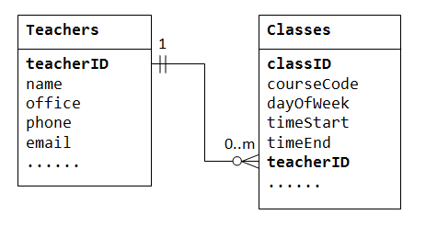

Figure 7 Relational Database

### **2.1.9 Cloud database:**

This type of database are also called virtual environment, hybrid cloud or public or private cloud because database that has been made for such a virtualized environment.

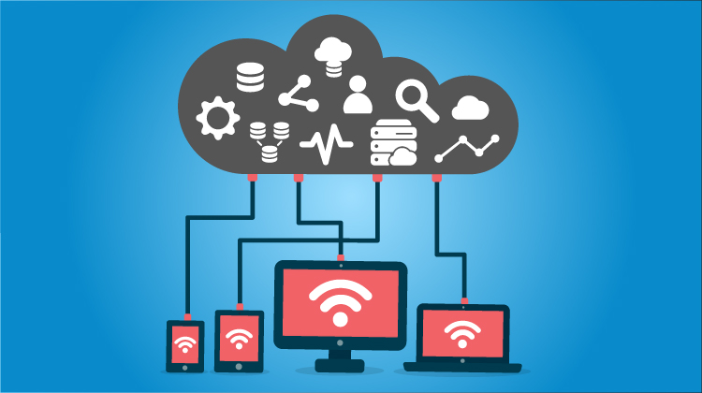

Figure 8 Cloud Database  (Wadhwa, n.d.)

### **2.1.10 Object-oriented database:**

It is a similar to object oriented programming language because this database contributes to a model with information denoted by objects. For example:

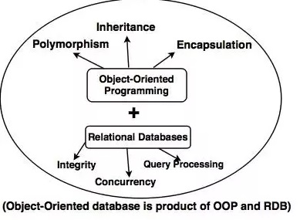

Figure 9 Object oriented database

### **2.1.11 Graph database:**

The database which is organize data in the form of a graph based on the mathematical principle of graph theory. For example:

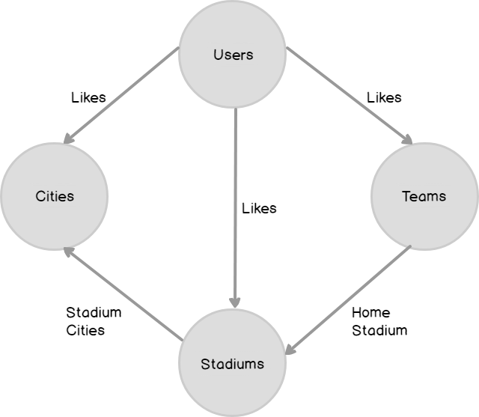

Figure 10 Graph Database  (Clarke, n.d.)

## **2.2 Secondary Research**

In 1972, two member of repute IBM group whose name are Donal D. Chamberlin and Ray Boyce who was proposing a new way to store and collect the data in an organization. That process of storing and handled the data of organization he called as Relational data model for the determined data. San Jose Research laboratory name this query language Structure English Query language (SEQUEL). After 4 to 6 years, new version of query is discovered name as SEQUEL/2 but had to be renamed to SQL due to some legal problem. In 1979, first commercial implementation of database released by unknown company named as Relational Software. This small and unknown company now becomes a popular as oracle. Johannes Zollmann describe about ACID property of RDBMS in his book and also describe this property consistency. Another researcher Antro note that for scale of the RDBMS only one way by add the hardware processing power and find out physical storage limit of database. Hence this database support current generation such as web, mobile and so on. This innovation is called as mother of innovation. After this innovation many users, developer and researcher facing a big data problem so researcher introduce NoSQL database. (Vyawahare, 2018).

[Markus Winand](https://winand.at/vendors) said that many NoSQL system claimed to solve all performance problems by features of horizontal scalability. In spite of the fact that for the present stage database flexibility is restricted to write activities and is refined with expected consistency model. A simple consistency model of SQL databases make slow down write and done tasks, still that doesn't really suggest terrible output.

NoSQL database is mainly used in big data. NoSQL divided into four types name as key values, Documents, Columns and Graphs. Every database has its own property so selection of type is depends in types of applications, requirements. Main advantage of NoSQL database are horizontal scaling, demoralization, Replication which is make NoSQL more powerful.

## **2.2.1 Features of NoSQL database**

* Horizontal scaling property: can store frequently required information in one table.
* To handle all the tables joins at application level.
* Data repetition is acceptable. So that helps to improve efficiency and execution speed of query.

## **2.2.2 Features of SQL database**

* ACID property:

A= Atomicity: atomicity state that either all the transection takes place at once or nor.

C=Consistency: in this property database must maintain their integrity constraints so that database equal in before and after. (Kaur, n.d.)

I=Isolation: In this property multiple process are done parallel without leading to the changeability of database.  (Kaur, n.d.)

D=Durability: in this property working after transection complete in a database which is stored the updates, deletes and modified data in a disk. This updates are permanent and non-volatile memory.  (Kaur, n.d.)

* Security: SQL maintain the confidentiality of the system in a database such as only authorized persons only access the system.

## **2.3 SQL and NoSQL database Migration process**

In oxford dictionary, in term of database migration is the movement of data in database from one database to another database to settle in another. For example SQL database data migrate in NoSQL database. In this process migration of database between two database (SQL and NoSQL) depending upon the style of NoSQL database. Hence migration of database depends upon which technology of NoSQL is selected for used. Many researcher research about gap between relational and non-relational database, also tried to cover the gap between relational and non-relational database. Graph database is a no relational database which is able to represent as a graph of any kind of data or information, logically accommodate changes in data. For example Cypher Gremlin is a graph data query language. In data migration, without sufficient knowledge of both database (relational and non-relational) source and target, it can cause serious legal, social and economy problem. In October 2011 oracle successfully migration of data n using of new technology. In the migration of data from one database (SQL) between another (NoSQL), developer need to knowledge about how to represent present model in another database, it means mechanism of both database system retrieval of data design in different method in both database.

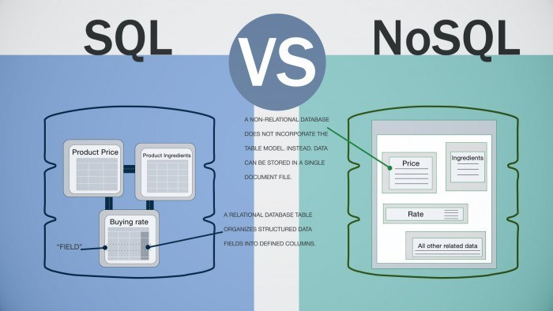

Figure 11 SQL vs. NoSQL  (Odendaal, 2018)

### **2.3.1 Different between NoSQL and SQL Database**

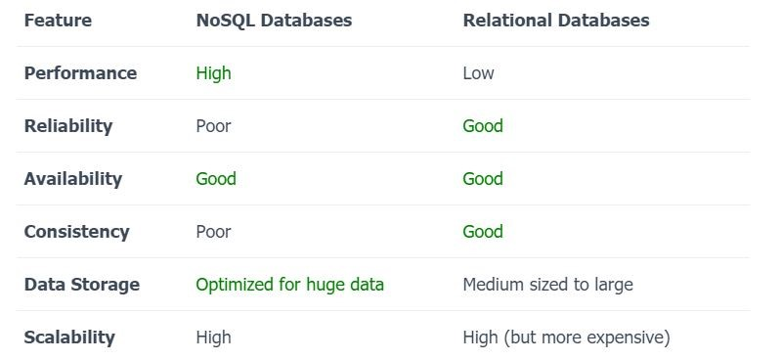

## **2.5 Disadvantage of NoSQL Database**

* Sometime NoSQL database does not support range queries and joins.
* NoSQL query structure is inflexible to increase user acceptance.

## **2.6 Disadvantage of SQL Database**

* Relational database are not flexible then graph database for any kind of data analysis.
* Complex structure of database cause difficulty to analysis of performing of data.
* Sometime RDB required complex join operational which is directly affect in the performance and efficiency of system.
* Static set of column which is not appropriate for big or huge data.

## **2.7. Conclusion**

In the analysis of SQL (Relational) and NoSQL (Non-relational) database, we can conclude that

1. Developing software’s are not a large but which medium type application is developed in relational database (SQL database).
2. In both database have inversely proportional of data storage and data performance structure so that there is some problem of data migration. This problem create query becomes slow in SQL database.
3. There for using of SQL database to develop house rental system.

# **III Methodology**

## **3.1 Introduction**

The process of collect, assemble, evaluate data and tools which help to collect related information in definite research dissertation is called methodology. The methodology summarizes tools for collecting data, how to collect data, structure method, system input and output, involved user and system improvement utensils (Henry Peter Gommans, 2014).

## **3.2 Fact finding methods**

In this methods, researcher directly and indirectly involved in collecting the data from the user of the system. Fact finding methods mainly divided into three part and collect the data from user. The data collecting methods are include as follow:

### **3.2.1 Objectives**

This method is used to collect information about operation of current running system and its process (Henry Peter Gommans, 2014). This system involved in continuous recording, surveillance the performance and features of existing system process. This process gives more details and situation related information but may be time consuming process.

### **3.2.2 Questionnaires**

In this method, I will developed many more questionnaires whereby I will deeper analyse about how the existing system working. This method is better method because this method provides more information about individual’s user and also better opportunity to restructure of question and their valuable answers. This method is more preferred because

* Provides closer contact between user and developer.
* Documents explanation
* High response rate then interviews.
* Get depth of information (Henry Peter Gommans, 2014).

### **3.2.3 Secondary data collections**

In this techniques, I will collect data from existing software, book, journals, and website, article where that was collected by other users or writer. This available data was compared with primary data and make valuable decision and useful conclusion  (Henry Peter Gommans, 2014).

## **3.3 System Development Methodology**

The technique used to show how the purposed system will be developed is known as system development methodology. In thesis, I will developed house rental system which system followed by waterfall methodology.

### **3.3.1 Waterfall Model**

In 1970 Winston Royce introduced waterfall model for the sequential development of software development life cycle. Hence also called sequential model because each phase design into definite task during SDLC. The developers are most be finished one stage or phase before going to next stage. Waterfall life cycle phase or stage are feasibility and requirement analysis, system design, implementation, system testing, system deployment and maintenance. This model is a simple and easy to use.  (Anon., n.d.)

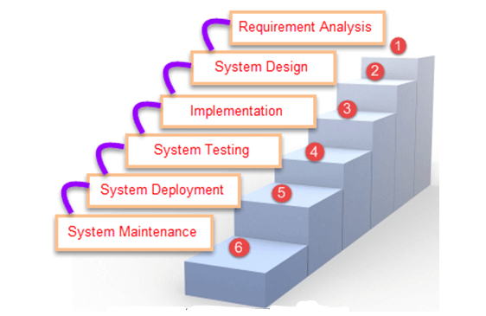

Figure 12 Waterfall Model

#### **3.3.3.1 Feasibility study**

Here, I will complete a research to increase an understanding of the clients (tenants) present system and issues experienced in this system through meetings, observations, and participations. I will utilize the got information to decide the practicality of the system being proposed term of technical, financial and social feasibility of the system (Henry Peter Gommans, 2014).

#### **3.3.3.2 Requirement Analysis**

In this phase, all the details of requirement of the system information are gather from tenants. Also include what the customer need, problem of system and their solution, has discussed about system compatibility, gather requirement of programming language, database model and hardware needed (such as laptop, mobile, printer etc..)

#### **3.3.3.3 System design**

In this phase, I will create an overall system architecture and physical interface such as user interface and database design. It is also called fault identified phase because if any fault in a system show in the time of design. The main purpose of this phase are design specification which is very helpful or necessary for next stage or coding phase.

#### **3.3.3.4 Implementation or coding**

In this phase, I will begin coding with the help of system design specification. The output of this phase are valuable product which is able give us useful information according to predefined code standard and debugging, tested to fulfilled the system design architecture.

#### **3.3.3.5 Testing**

In this phase, I will ensure that system are error free and fulfil the user requirement and also verified that both individual and integrated are methodologically system are error free. I will done all testing such as unit testing, acceptance testing, and functional testing of the integrated product. Also get ready, review and published product documentation at this phase.

#### **3.3.3.6 System deployment and maintenance**

After testing phase, I will ensure that system is ready for use at customer site. In this phase, installation of product in client site, modification on the system to improve system performance, if any bug is display in client cite to solved this and most important part of this phase are record for changing system, update documentation and system update.

# **IV. System analysis and requirement Modelling**

## **4.1 Introduction**

The system destinations plot during the achievability study filled in as the premise from which crafted by system design was started. A significant part of the exercises required at this stage were of specialized nature requiring a specific level of involvement with planning frameworks sound information on PC related innovation and through comprehension of PCs accessible in the market and the different offices gave by the sellers. In any case, a framework couldn't be planned in disconnection without the dynamic inclusion of the client. The client had an essential job to play at this stage as well. Information gathered during possibility study was used methodically during the system plan. Planning a framework is an inventive procedure which calls for intelligent just as horizontal reasoning legitimate methodology includes efficient moves towards the end item remembering the abilities of the work force and the gear at each structure making step.

## **4.2 Existing System**

In the Nepal most of house rental system are paper based system. House owners maintain property and tenants details as well as payment system on paper. If any tenants finds out the vacant room, they can call or meet the house owners to fixed rent per month, payment system, terms and conditions of house etc.

## **4.3 Problem of existing system**

Some limitation of existing system are given below:

* Entry of user data in paper based register.
* Existing system only provides text based system which is not user friendly and user interface (Henry Peter Gommans, 2014).
* Both owner and tenants have different paper based files.
* Paper lost problem
* Manual conversation between tenants and owners and that is not any proof.
* Response is very slow.

## **4.4 Requirement Analysis**

Requirement of analysis defined as user needs and objectives fulfil in user used, system character, user request, external and internal environments which is affected directly and non-directly in the system to determine requirement of system functions.

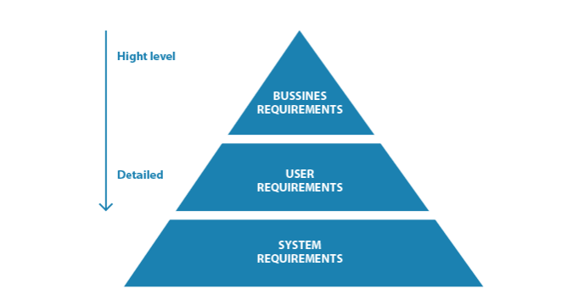

Figure Requirement Analysis

### **4.4.1 User Requirements**

This is defined as user involvement, statement of system in term of objectives, external and internal environment, reliable of the system, measure of effectiveness and suitability. Mainly user requirement needs as

* System effectiveness: system improves efficiency of the information in the form of storage and retrieval.
* User friendly: system must be easy to learn and used.
* Robust: system must be fast (fast in Processing transection), safe and flexible

### **4.4.2 Functional requirements**

Functional requirement defined as function of system and its components where function is defined as specification of behaviour of input and output in the system. Functional requirement involve in data manipulation, technical details, system processing, functionality of system etc... Functional requirement of house rental system are given below:

* Admin to add house, tenants details
* Admin can delete, update house, tenants details
* Admin can search and sort data in the database.

### **4.4.3 Hardware Requirement**

Laptop with 2 GHz processor speed, 4GB ram

Printer for documentation print

### **4.4.4 Software Requirement**

* Minimum window 7 operating system
* Microsoft office ( documentation and presentation)
* XAMPP
* Apache server
* Bootstrap4
* SQL database
* Atom IDE

# **House Rental System application: Tools and technology**

The set of external and internal computer programs and system that tools and technology used to create software, debugging, and supporting other system or application or programs is called software tools and technology. The development of house rental system, the tools and technology that were used are HTML, MySQL database, PHP (hypertext pre-processor) language, CSS and JavaScript. And also used apache web server and phpMyAdmin. Above mentions tools and technology are used between many other because these tools and technology are most reliable, free, and easy to use. Description of above tools and technologies are given below:

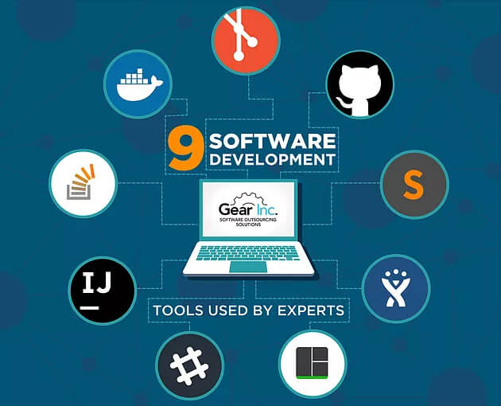

Figure Software tools

**5.1 Github:**

Git is an open source version controlling system that control and keep these revision strength, store modified data or code in a centre repository. Github is a development platform motivate by the technique we are work. In github, we can host, review, manage and build code and project.  (Github, n.d.)



Figure github logo

## **5.2 PHP:**

It is an html and CSS embedded server side scripting language which is design for web development. Rasmus Lerdorf developed PHP in 1994 and distributed in the IT market in 1995. Most of the syntax is burrowed or copy by Java, C and C++ language. In starting of 2001 nearly five millions php domain in worldwide and PHP domain user rapidly increases. The main challenger of PHP are java, ASP, .Net etc.

The PHP is viewed as the best choice for building dynamic applications which speak with databases, a key reasons to pick is that has worked in capacities that communicate with an enormous number of commercial database system. Following are the example of the PHP which is used to connect with MySQL database:

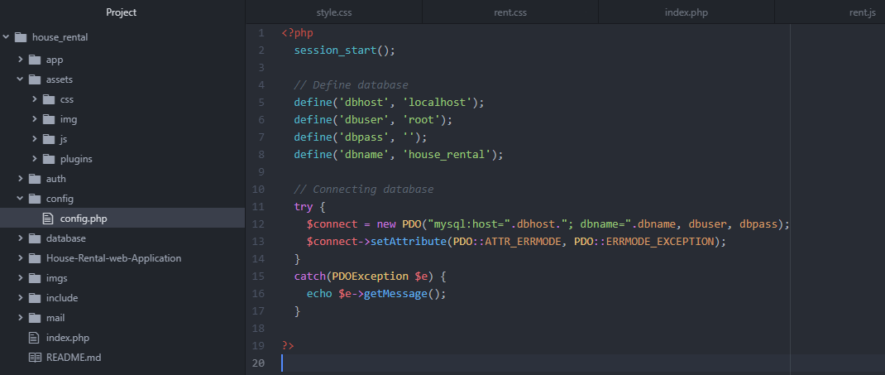

Figure PHP syntax: connections to MySQL database

Comparison of these language, PHP is better than other in this product because:

* Allow developer to create dynamic web page quickly.
* Free of cost
* Available of source code
* High performance
* Support all must all have database.
* Easy and understandable syntax.
* Support with all server.

**5.3 MySQL Database:**

It is a type of database where database are categorized by a set of table with multiple row and column where data grows fits into predefined class. MySQL is the standard user and applications programmer interfaces for relational database (Java TPoint, 2011). MySQL database is a very fast and strong database because database perform storage, retrieve, and sort/search effectively. Also controls the numerous users with multiple data access and declaration that only valid user have right to use in a system. MySQL used SQL standard language queries so that it is multi-threaded server with many users. It is also gives for connection to many different database such as SQLite, MS-SQL, IBM etc.

### **5.3.1 Advantage of MySQL**

Main competitor of MySQL database are MS-SQL, SQLite and oracle. So that MySQL is popular than other database because:

* Low cost(Free available): this is available in free open source
* Easy to use: In now day many database using SQL database so that we are not problem when we used another system database.
* Performance: It is fast.
* Portability: this database using in different linx system and Microsoft windows.
* Version Up to date.

### **5.3.1 Operating system of MySQL**

Operating system of MySQL database are given below

* User open the browsers and search something, this process web HTTP request for specific website.
* The web server received the request from web browsers and passed to PHP to PHP engine for processing.
* PHP engine process and analyse of the script. If all are ok then connect to the database and execute database.
* MySQL server received the database queries and send the result again PHP engine.
* PHP engine stop their searching query and send available result in HTML page (front page of system).
* Web server passes the HTML file to the browsers then user can views the data

## **5.4 Apache web Server**

It is popular, fast, stable and safe web server which available in internet with free of cost and maintenance more feature in than any other server. In now day 80% of user used apache server. So that millions system install apache server which is hits millions of times in apache server daily without showing any problem. Now day, apache server is most stable server in worldwide. Hence, it should be worried in many commercial servers such as HTTP server using core apache.

## **5.5 XAMPP**

It is free program software

The XAMPP is free program system software with zero expense. A package is important for XAMPP, which set of bundle integrates the most recent version of Apache HTTP Server, the PHP and the MySQL database, compilers situations written in the programming language PHP and Perl, and furthermore three other valuable devices which are vital (PhpMyAdmin, Filezilla Server, and Mercury Mail).

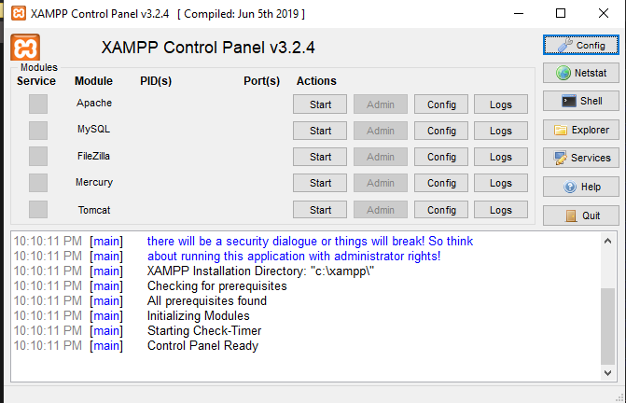

Figure XAMPP control panel

Full form of XAMPP are

X -> crossed platform

A -> Apache HTTP server

M -> MySQL database

P -> PHP language

P -> Perl language.

XAMPP is suitable for different type of operating system such as Microsoft windows, Mac OS, Linux and UNIX. XAMPP is mainly used for developing web project.

### **5.5.1 Functionality of XAMPP**

The functionality of XAMPP are given below:

* Independency of operating system (OS)
* Independency of Browser (run and availability in any browsers)
* User-friendliness to controlling by the instructor.

### **5.5.2 Installing process of XAMPP**

Step of installing process of XAMPP are as follows:

1. Go to favourite web browser to type <https://www.apachefriends.org/download.html>
2. Select XAMPP for available OS (windows, MAC OS or Linux) any one.
3. Installation process are given in appendix.

## **5.6 PhpMyAdmin**

It is a free open source software and manage the MySQL database. These can be operate fully databases, tables and whole MySQL server. PhpMyAdmin support more than 47 languages. Some function of phpMyAdmin are to:

* Create, update and delete database
* Import and export database
* CRUD functions of tables in existing database
* Copy and rename of database or tables
* Perform SQL queries to database
* Loads text files into database tables
* Manages the users and their authentic

**5.7 Er Diagram:**

Display the relation of entity stored in a database is called entity relationship diagram. It is also called high level conceptual data model diagram. Uses of entity relationship diagram are:  (Guru99, 2019)

* Connection between table
* Describe about entity, attributes and their relationships.
* Help to quick create database.

For example, database of Softwarica College, their student, course and lectures have entities. The Roll no, name, section can have attributes of student entity.

**5.8 Photoshop:**

Photoshop is adobe’s photo editing software which help for us to image creation and graphic design in a system. We are used in Photoshop in the time of software development process because  (WhatIS.com, 1999-2019)

* This software provide many image editing features.
* It is uses layer based editing system which is allows image formation and changing with multiple connections that support photograph.



Figure logo of Photoshop

## **5.9 HTML**

Full form of HTML is Hypertext Markup Language which is characterized of ultra-language text and language based on Standard generalized markup language (SGML). SGML is a very large system of document processing. It is simple type of text files which can contain text, form, images, links etc. To make a HTML record a straightforward text editor is sufficient. The HTML characterizes a lot of normal styles for Websites, for example, titles, headings, paragraph, records and tables. Likewise characterizes character styles, for example, boldface and the segments of code.

Every component has a name and is contained inside the symbol<>, which are called tags. At the point when somebody is composing a Website with HTML, in the substance is offering titles to the different components of the page with these tags. The Browsers, alongside the capacity to recover pages from the Web, additionally work as formatters for HTML. At the point when somebody checks a page which is written in HTML from a browser, the browser translates the HTML tags and formats the content and images on screen. Various programs, which run on various PCs, can assign out various styles to every component of a page. This indicates pages made with HTML may appear to be totally unique from system to system and browsers to browsers. Hence, in genuine data and connections contained in these pages will consistently be there, however the presence of the pages on the screen will be unique. Example of HTML in house rental system are

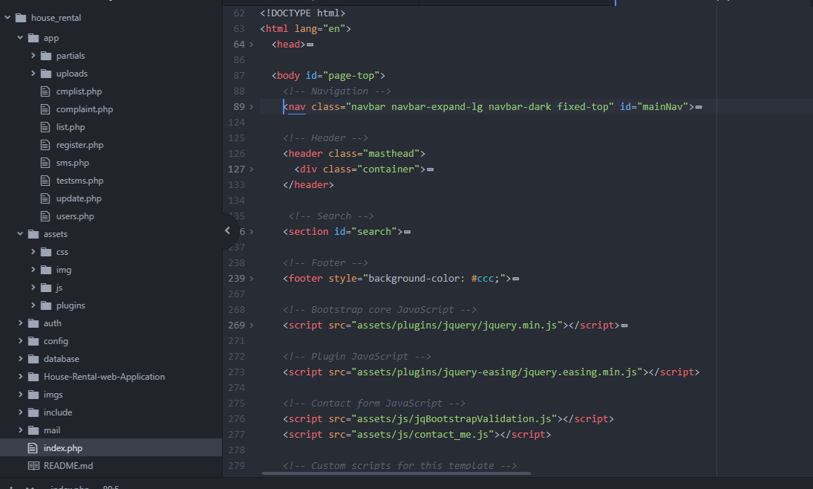

Figure HTML Format

## **5.10 CSS**

Full form of CSS is Cascading Style Sheet which is helps to change of appearance and layout of the web applications. The knowledge of CSS is most important because this save us a lot time, effort and performance of the system. To work with the CSS we don't have to utilize a program for making pages, known as FrontPage, or Dreamweaver or Word, as it will ruin the knowledge of CSS. What we need is a basic text editor such as notepad in windows. Example of css format:

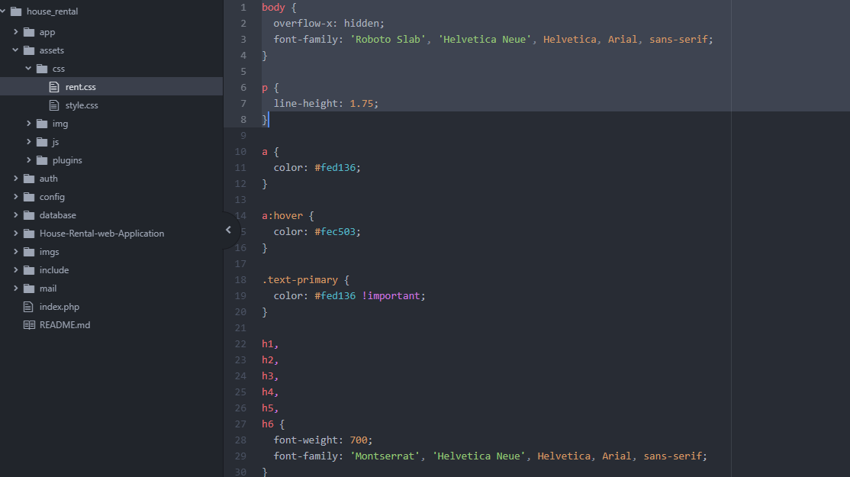

Figure CSS of house Rental system

### **5.10.1 Advantage of CSS**

Some advantage of CSS are given below:

**File size:** CSS file size is smaller because each rule of formatting is written only once and not all applied.

**Maintain of website:** CSS easily maintain the web page because the appearance of all site can be handle by single .css files. So every adjustment in the style of the site can be made with an extraordinary change in this record as opposed to preparing numerous focuses in each page that is on the site.

**Faster:** When utilizing outside record of CSS, the browser the first time when you load a page of our website frees in reserve, so there is no compelling reason to download it again every time the client downloads another page of the webpage.

**Greater Flexibility:** The CSS completed ​​potential the formatting which was impossible or very problematic with standard HTML.

## **5.11 JavaScript**

The programming language of JavaScript created by the organization of Netscape, as a team with Sun Microsystems and its first version was distributed in 1995. It was parallel language which was named Microsoft Jscript and the second version of JavaScript was called ECMAScript later it was built up with the name that is known JavaScript. The JavaScript is one translated programming language with properties of item situated programming language, yet can characterize as complete entity. JavaScript was basically based on the example of language C, C + and Java. Then again it has an extremely critical different that oversees data types all the more roughly composed comparative with the tight administration of specifically information that happens on those dialects. In JavaScript the variable are not important to have a particular press or may change type during their life. Likewise, somebody should not to confuse the JavaScript for Java of Sun Microsystems. The first isn't identified with the other. The utilization of the JavaScript was for purpose of the language when the spread of Java were enormous. For example of JavaScript in house rental system are given below:

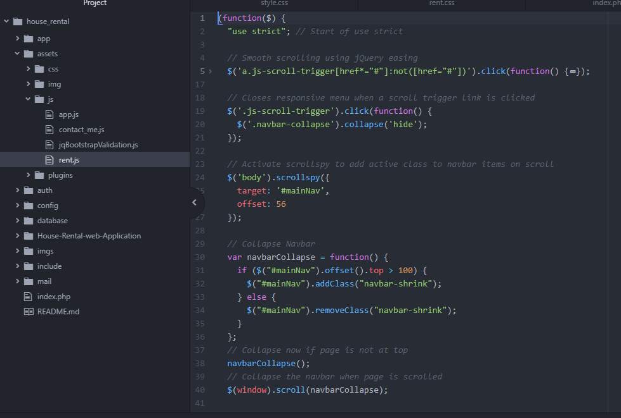

Figure rent.js in house rental system

### **5.11.1 Uses of JavaScript**

Following are the uses of JavaScript

**Fast running on a server**: The control and information approval entered by clients is done from the side of the program so information which isn't in a reasonable structure are not sent in the server. This doesn't imply that the review demonstration from the side of the servers as a client might not have implanted of JavaScript in the program, or may have it handicapped.

**Direct interaction with user**: With the utilization of JavaScript in information control the holding up time of clients was decreased since they don't need to stand by significant stretches reloading the page in the event that that somebody has neglected to present any information or have entered something incorrectly.

**Auto corrections of mistakes**: One model that can make increasingly reasonable how this can be utilized in JavaScript hence is the date. A great deal of Database system store information in dates group dd-mm-yyyy. In the event that a client enters a date in structure dd/mm/yyyy then this could be recognized consequently by the program and changed over to the right configuration before the information is sent to the server.

**Better usability:** This is accomplished by enabling the client to change and to associate with the GUI without reloading the page. One such model is the collapsing menu.

## **5.12 Technical Specifications**

### **5.12.1 Usability**

Suggests to the simple entry or potentially utilization of the system to pick up the necessary objectives successfully and productively. For example: system must be user-friendly. House rental system is user-friendly because easy and clear navigation bar and menu (DDI Development, 2019).

### **5.12.2 Availability**

Implies that a framework is completely operational and works well when it's required. For example: the system must be available 24/7. House rental system is available when user mood to used system (DDI Development, 2019).

### **5.12.3 Scalability**

Depicts the capacity of the framework to perform under expanded interest. For example: to support more and more user. House rental system is support many user in simultaneously.

### **5.12.4 Performance**

Alludes to the system responsiveness when different sort of clients are connecting with the system/programming. For example: website load less than 1.5 millisecond. House rental system loading fast due to the local server Apache server  (DDI Development, 2019)

### **5.12.5 Reliability**

Portrays the capacity of a framework to work under expressed conditions for a predetermined time span. For example: house rental system is reliable because database must be backed due to help of PhpMyAdmin.

### **5.12.6 Security**

Spotlights on information security and anticipate unapproved get to. For example: house rental system fulfill the security such as user authentication, provide right of entry only to valid users. PHP and phpMyAdmin maintain the security of house rental system  (DDI Development, 2019).

### **5.12.6 Version control**

Github helps to controls system version control in a system. House rental system used github to control their version control.

# **VI. Project Plan**

Project plan is the most important part or task in a system development, so it is also called project success key. In this plan the most important document are created such as project starting and ending time and also display project small task and their ending and start date. It is a type of agreements between project customers and project developer. In this thesis, project plan discusses to a Gantt chart (Techopedia, n.d.). Gant chart is used as following resone:

* To calculate and control the project time.
* To calculate and control delivery and timetable.
* Easy to create documentation.
* Easy to communicate with stakeholder and developer.
* It is open source software.

This thesis Gantt chart are given below:

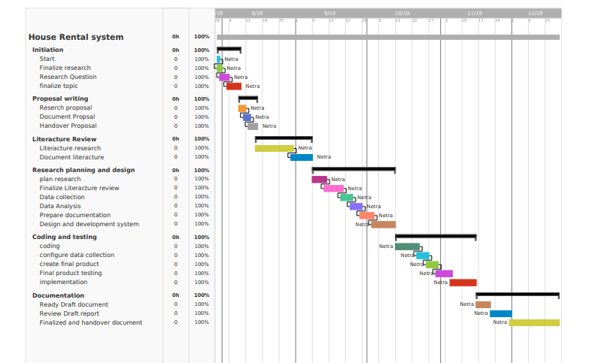

Figure Gantt chart

In above Gant chart, project is divided into 5 small task. Which is initiation, literature review, design and planning, coding testing and documentation, finalize documentation. Project start date July 30, 2019 and end date is December 20, 2019. Some task start date and end date are given below:

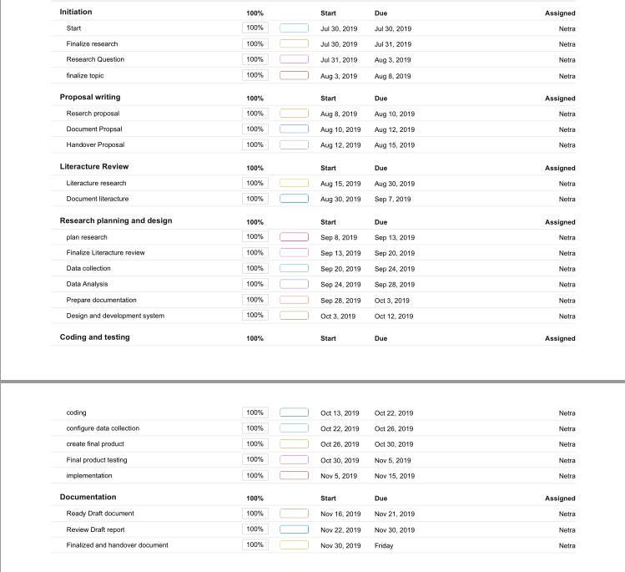

Figure List of working flow with date

# **VII. System Design**

## **7.1 Design Phase**

This phase said that analysed the document of user requirements for better understanding of what was required of the system. Analysed of this requirement in the ways of implementation. This phase are also called visual basic system because physical models of system were design and identified of working or operating environment, so that we are work on. Only authorized person such as system admin can do that process because they have authority and allow to access to the system, CRUD functions of the database. Users add account in users table in a database with add details in the database.

## **7.1.1 Conceptual Design**

The conceptual design phase helps to provided description of the system to set integrated ideas and to let know how to do, so that user can easily understand the manner intended. This design is the first stage of system design. This design sketch were dominants tools and products.

Admin

Tenants

System

### **7.1.2 Database Design**

The main them of database is to handle information as an integrate whole.it also used to collect inter related data stored with less secondary to make uses easy and effective. After designing input and output. The analyst should concentrate on database design so that data should be organized by user’s requirement. Its main objectives is to make data flexible, easy and fast for user.

User table

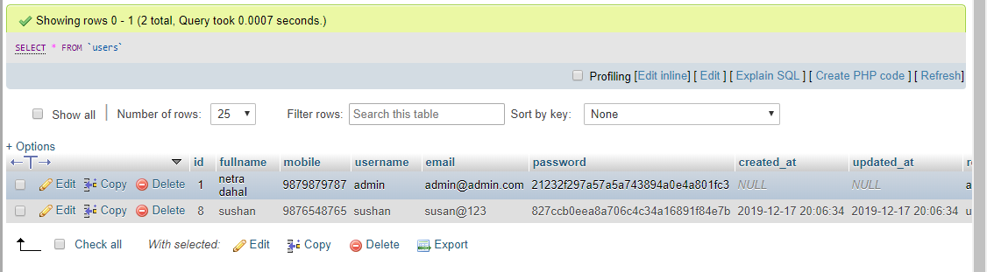

Table user table

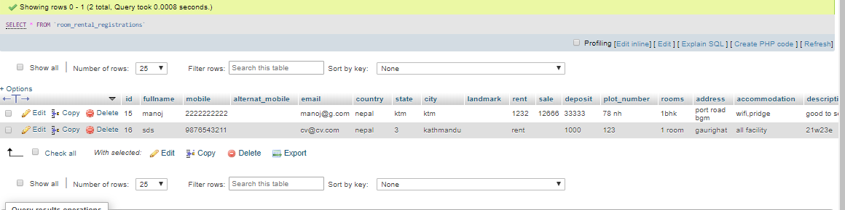

Table Add house

## **7.2 Software Interface**

Login page

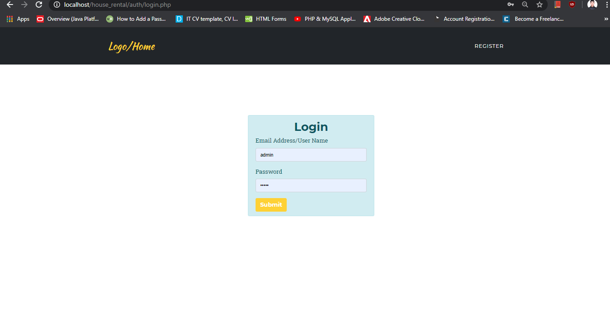

Figure Login page

Register page

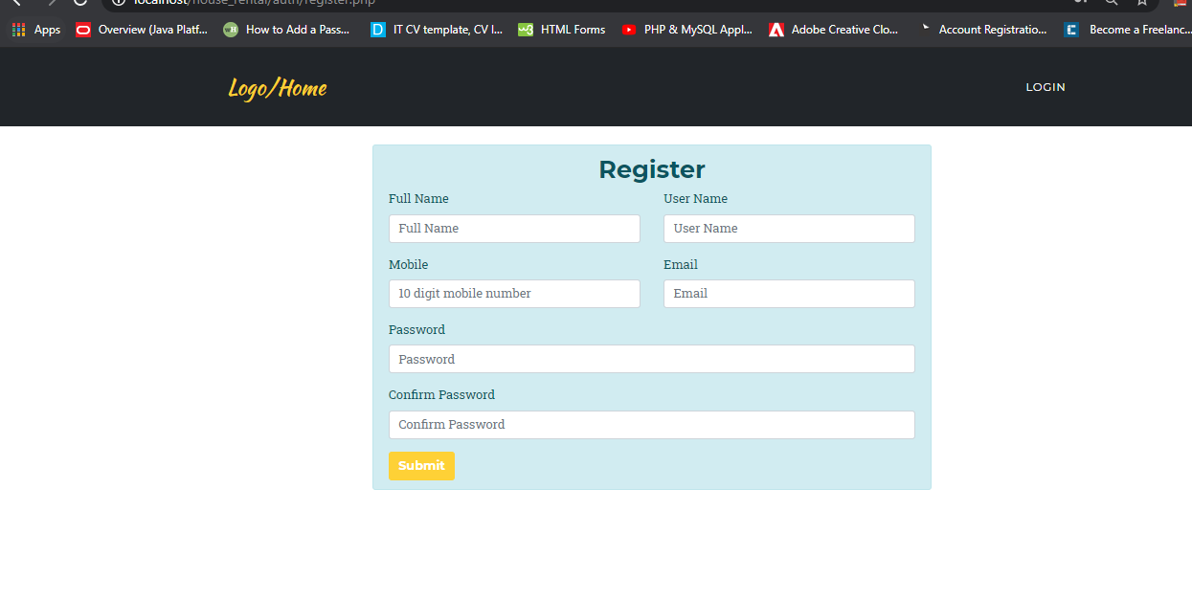

Figure Register page

Admin Dashboard

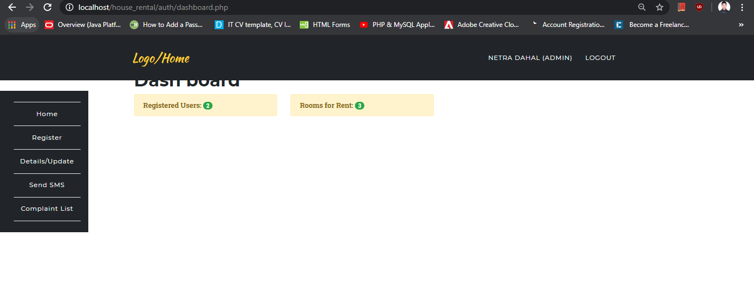

Figure Admin Dashboard

Index page

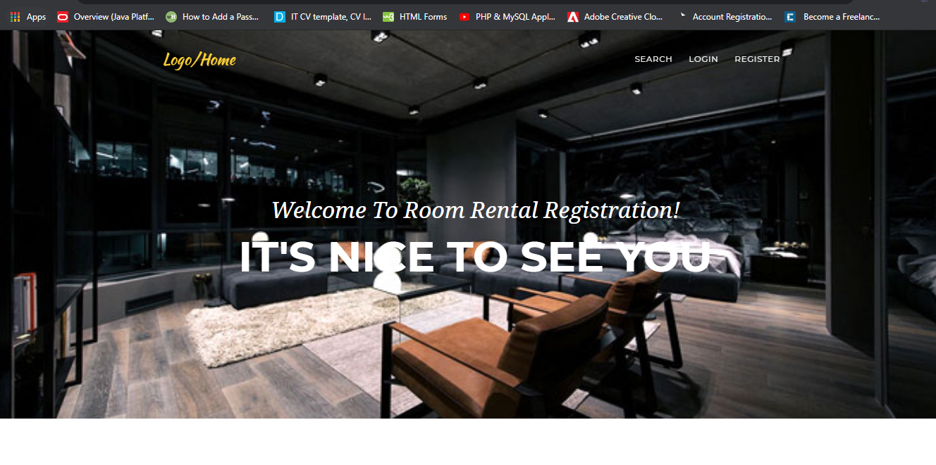

Figure Home page

Searching home/ room/ flat

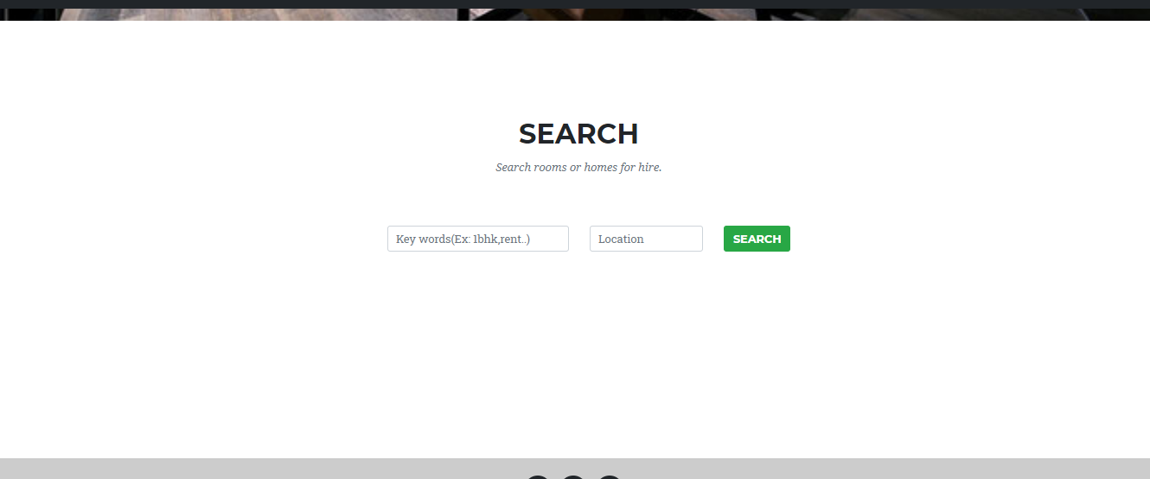

Figure Search

Room Add

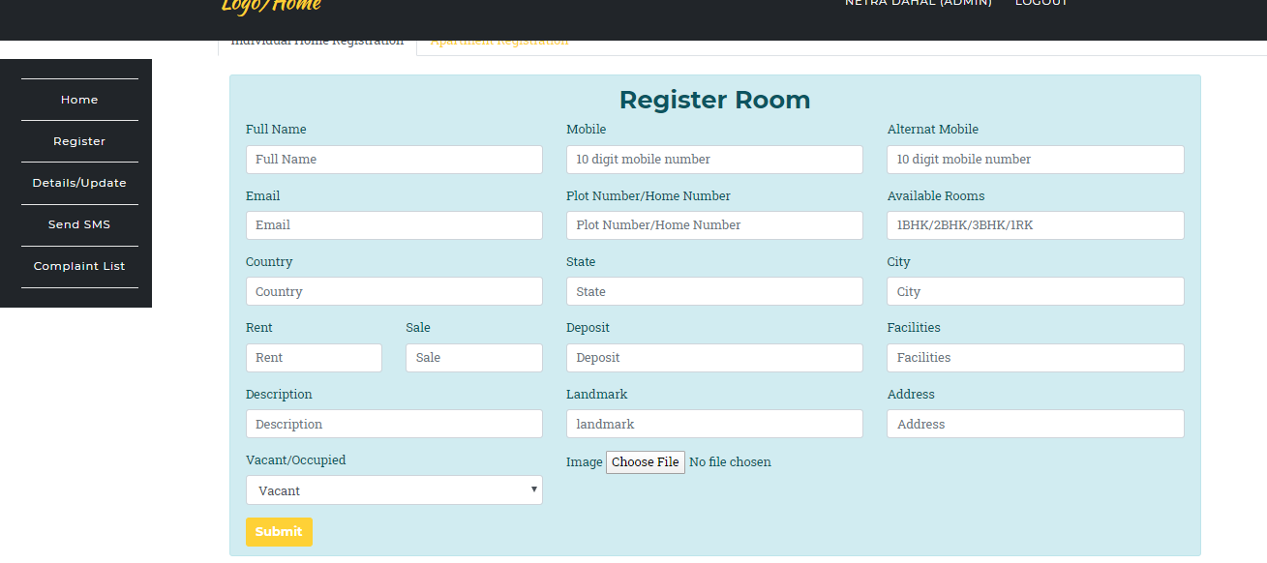

Figure Room Register

Room/ flat/house update

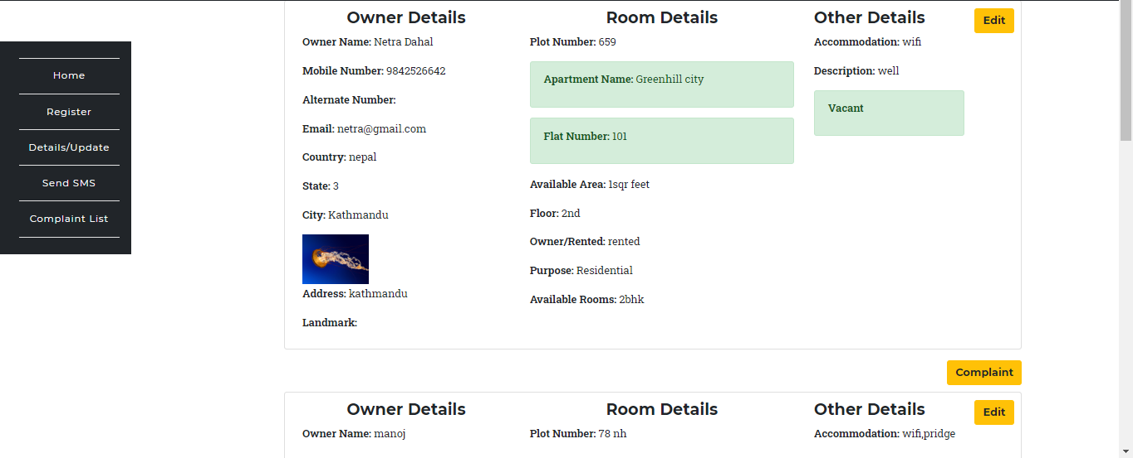

Figure Update table

Complaint list

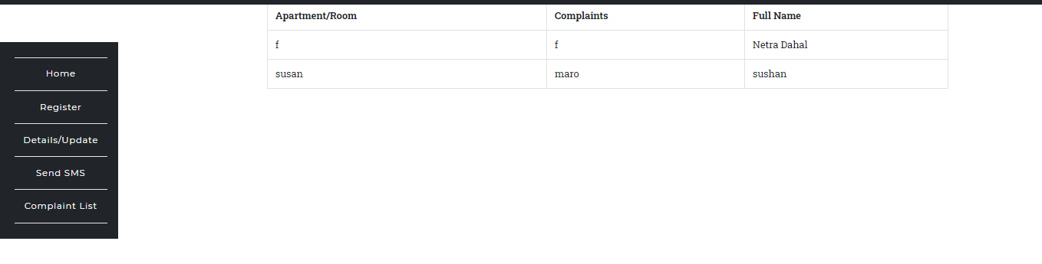

Figure complaint list

# **VIII. System Implementation and testing**

## **8.1 System Implementation**

Implementation is the stage of a project where conceptual or theoretical system is converted into working user friendly system. There is many activity done in a implementation stage such as builds, install and operates new system. This is most important and critical stage in completing a new system that work efficiently, successfully. Some activity maintain below which is involved while implementing a new system  (Henry Peter Gommans, 2014)

### **8.1.1 End user Training**

It is a part of implementation because the staff of an office must be train about new technology. Department staff is main role and involvement of successful implementation of new system so we are train the department staff.

### **8.1.2 End User education**

After testing and implementation, end user are going to educate about new system. If system is found more difficult to understand and complex then more effort about education for end user to make aware of the system, provides documentation, system working video, working flow diagram, lectures about new system etc…

### **8.1.3 Training in the application software**

After giving new system education and basic training about computer to provide a new system such as check validation, error type while entering the data, method to correct the data entered, screen flow and design etc. it is more necessary that user which is working in a new system in daily. So, all the basic concept and using methodology are train in specific user use the system.

### **8.1.4 Post implementation Review**

Development Company are planned about regularly meeting in a officer because the previous implementation are success or failed. This process is called state of the past implementation process.

## **8.2 System Testing**

System testing is process of find out any error, gaps and missing requirement different to the given requirement. In other words, system testing is process of calculating a created system with its committed requirement and sure that all requirement fulfil or not (tutorialsPoint, n.d.). The motivation behind the system testing is to consider all the likely varieties to which it will be recommended and push the frameworks to limits. The testing procedure focused around the authentic interval of the programming guaranteeing that the sum total of what declarations have been test and on useful interim is directing tests to reveal mistakes and guarantee that characterized info will deliver genuine outcomes that agree with the necessary outcomes. Integrated testing, Program level testing, modules level testing completed. There is many type of testing such as agile testing, functional testing, non-functional testing and automation testing so on (Anon., 2019). But we are discussed about two major testing, they are white box testing and black box testing.

### **8.2.1 Black Box Testing**

In black box testing, the main motivated of testing is functionality of system without knowing about internal structure, design. Hence only focused on input and output of the system. Black box testing is also known as behavioural testing because it analyse the behaviour of the system. This testing is both available functional and non-functional. Ranorex Studio is the tools which is done black box testing. Disadvantage of black box testing are sometime some bugs that cannot be find out (Anon., 2019). Black box find out flowing error:

* Interface error
* Data structure performance
* Performance error
* Conclusion error

### **8.2.2 White box testing**

Testing about internal process of a project and evaluating code is known as white box testing. This testing is also known as structural testing because it is involves test for structure of the code. Some coverage of white box testing are code coverage, basis path testing, branch coverage, data flow testing, and path testing, loop testing etc.  (Anon., 2019). some benefits of white box testing are:

* Logical error: Some time, project have logical error because conflict between logical flow and actual implementation. That’s time we are found out system problem due to the help of white box testing.
* Syntax testing
* Usability error
* Check all logical decision in the system

# **IX. Recommendation, future work and Conclusion**

In this chapter, I am summarized all the process and system and complete the paper. I can also describe about recommendation and future work. Future work is the type of work which I cannot capable to do because some conflict I face during my research. I am also included what next in a future.

## **9.1 Recommendation**

Our system is proposed to fulfil the requirements of house rental landowners. A few easy to understand interfaces have likewise been embraced. This project will demonstrate to be a ground-breaking in fulfilling every one of the requirements of the clients. It is with most extreme confidence that I present this product to user trusting that it will take care of our issues and need you to keep acknowledging innovation since it is intended to change and facilitate all our work that is by all accounts troublesome. I don’t suggest that my undertaking is the best or that I have utilized the best innovation accessible it only a straightforward and a modest effort that is straightforward.

Hence, I would empower any individual who can knowledge about advance system, it utilizing cutting edge innovation in order to expand its abilities.

## **9.2 Conclusion**

### **9.2.1 Summery of SQL and NoSQL Database**

In the analysis of SQL (Relational) and NoSQL (Non-relational) database, we can conclude that

1. Developing software’s are not a large but which medium type application is. So that we can used relational database (SQL database) to developed House rental system.
2. In both database have inversely proportional of data storage and data performance structure so that there is some problem of data migration. This problem create query becomes slow in SQL database.
3. Finally uses of SQL database to create house rental system.

### **9.2.2 Summery of Product (House Rental System)**

In this thesis is presented house rental system which has web application to store tenants and owners data in database. The product can be utilized as a house rental system to give an edge work that empowers the troughs to make sensible exchanges made inside a constrained time allotment. Each exchange made on the system go inseparably with the information being refreshed in the database for our situation it is MySQL, HTML, CSS, JavaScript and PHP. Which is the back end and front end. To wrap things up it isn't the work that played the approaches to progress yet  (Henry Peter Gommans, 2014).

### **9.2.3 Personal Reflection**

Research of this dissertation, I was gained lot of good things, research about another research. Also search and research different type of articles, books, internet to gather information for this dissertation. This type of research was new for me but also tired because of gather of information for this thesis but I manage all pressures and accept the challenges. Hence, I was also ready everything in time.

## **9.3 Future Work**

Some future work of House Rental System are given below:

* Tenants or house owner can contact with fire services if needed.
* House owner can receive money by online banking services.
* Password verification problem will be solve easily by this system.

# **10 Bibliography**

Anon., 2019. *Black Box Testing.* [Online]   
Available at: https://www.softwaretestinghelp.com/black-box-testing/  
[Accessed 01 12 2019].

Anon., 2019. *type of software testing.* [Online]   
Available at: https://www.softwaretestinghelp.com/types-of-software-testing/  
[Accessed 27 11 2019].

Anon., 2019. *white box testing techniques with example.* [Online]   
Available at: https://www.softwaretestinghelp.com/white-box-testing-techniques-with-example/  
[Accessed 01 12 2019].

Anon., n.d. *what is sdlc or waterfall model.* [Online]   
Available at: https://www.guru99.com/what-is-sdlc-or-waterfall-model.html  
[Accessed 05 10 2019].

Clarke, J., n.d. *An Introduction to Graph Database.* [Online]   
Available at: https://towardsdatascience.com/an-introduction-to-graph-databases-cd81a0d5aa12  
[Accessed 04 December 2019].

DDI Development, 2019. *how to write software requirement.* [Online]   
Available at: http://ddi-dev.com/blog/programming/how-to-write-software-requirement-specification-for-your-project/  
[Accessed 11 12 2019].

Dictionary, O., n.d. *what is migration.* [Online]   
Available at: https://www.ourmigrationstory.org.uk/about/what-is-migration.html  
[Accessed 26 09 2019].

Django, n.d. *the web framework for perfecttionists with deadlines.* [Online]   
Available at: https://www.djangoproject.com/  
[Accessed 12 11 2019].

enago academy, 2019. *what is the ethical considration in research design.* [Online]   
Available at: https://www.enago.com/academy/what-are-the-ethical-considerations-in-research-design/  
[Accessed 05 12 2019].

Github, n.d. *The world' leading software development platform.* [Online]   
Available at: https://github.com/  
[Accessed 15 10 2019].

Guru99, 2019. *ER Tutorial in DBMS.* [Online]   
Available at: https://www.guru99.com/er-diagram-tutorial-dbms.html#4  
[Accessed 20 11 2019].

Henry Peter Gommans, G. M. N., 2014. *Rental house management system | IJSRP.* [Online]   
Available at: https://www.academia.edu/9498812/Rental_House_Management_System  
[Accessed 23 11 2019].

Java TPoint, 2011. *what is hypertext preprocessor.* [Online]   
Available at: https://www.javatpoint.com/php-full-form  
[Accessed 23 11 2019].

Kaur, A., n.d. *Acid property in dbms.* [Online]   
Available at: https://www.geeksforgeeks.org/acid-properties-in-dbms/  
[Accessed 27 09 2019].

Odendaal, A., 2018. *relational(SQL) vs NoSQL database models.* [Online]   
Available at: https://ao.gl/relational-sql-vs-nosql-database-models/  
[Accessed 27 09 2019].

Techopedia, n.d. *what is project plan.* [Online]   
Available at: https://www.techopedia.com/definition/24775/project-plan  
[Accessed 17 11 2019].

tutorialsPoint, n.d. *Software testing.* [Online]   
Available at: https://www.tutorialspoint.com/software_testing/software_testing_quick_guide.htm  
[Accessed 15 11 2019].

Vyawahare, H., 2018. *Brief review on SQL and NoSQL.* [Online]   
Available at: https://www.researchgate.net/publication/326625099_Brief_Review_on_SQL_and_NoSQL  
[Accessed 25 09 2019].

Wadhwa, D., n.d. *Top-reasons-can-not-ignore-cloud-database-technology.* [Online]   
Available at: https://www.xcellhost.cloud/cloud-blog/top-reasons-can-not-ignore-cloud-database-technology  
[Accessed 22 09 2019].

WhatIS.com, 1999-2019. *what is photoshop.* [Online]   
Available at: https://whatis.techtarget.com/definition/Photoshop  
[Accessed 10 11 2019].

# **Appendix**

## **SWOT Analysis**

A SWOT analysis evaluates the internal strengths and weaknesses and the external opportunities and threats in an any type of research/ project. The internal analysis is used to identify, resources, capabilities, core competencies, environment etc... The external analysis identifies market opportunities and threats by looking at competitor’s resources, environment. SWOT analysis of smart rental system are given below

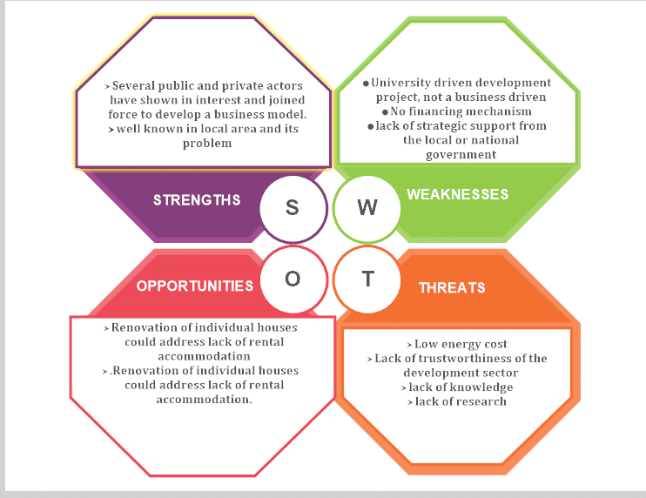

Figure SWOT Analysis

## **Installation Process**

### **XAMPP Install process**

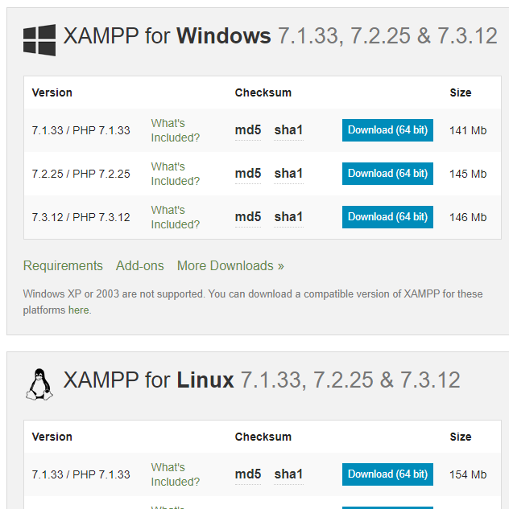

1. Click download folder option

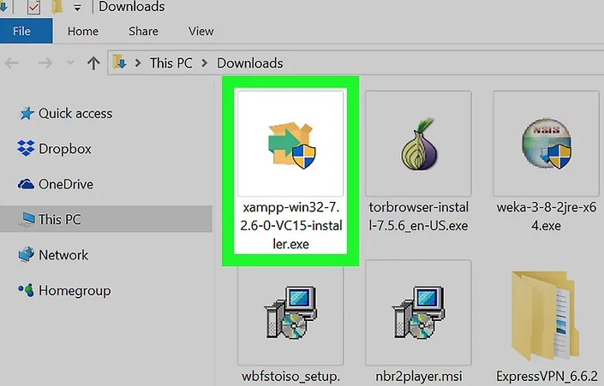

1. After download then double click XAMPP.exe file
2. Click yes

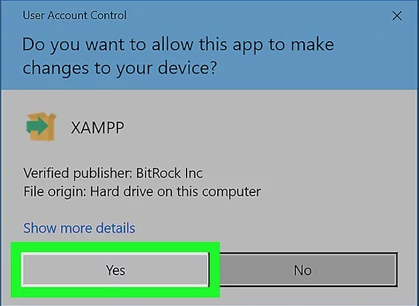

1. Click wizards setup

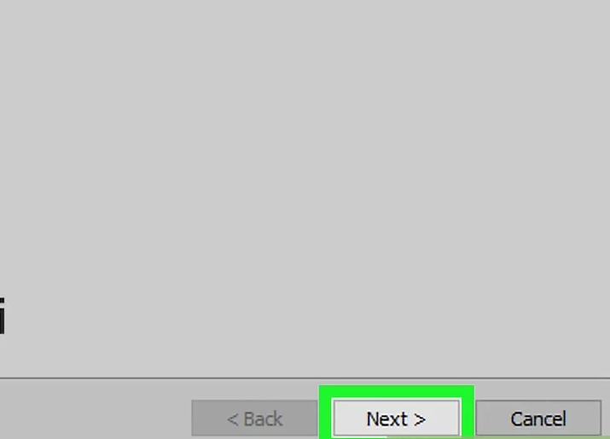

1. Select components

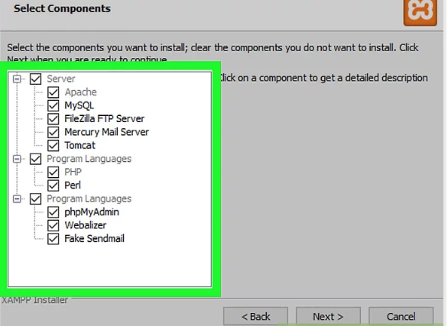

1. Installation folder

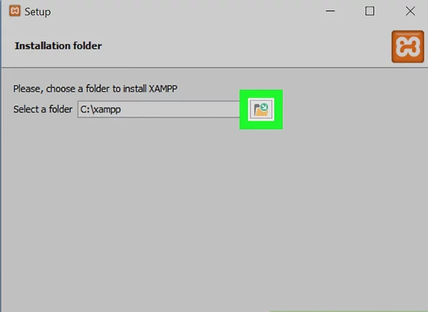

1. Choses language

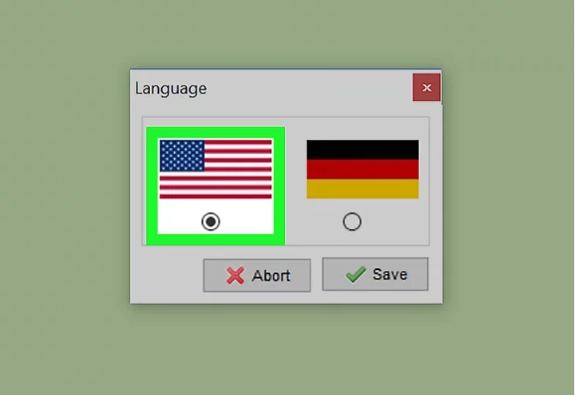

1. Then click next, next and finish

After finished installation process, returns to the desktop to display XAMPP control panel icon. Double click of this icon then following type of XAMPP control panel display



In above image, click the start button in Apache then the local server running.

### **Coding Of House Rental System**

All code are given in Github.

#### **Admin Page**

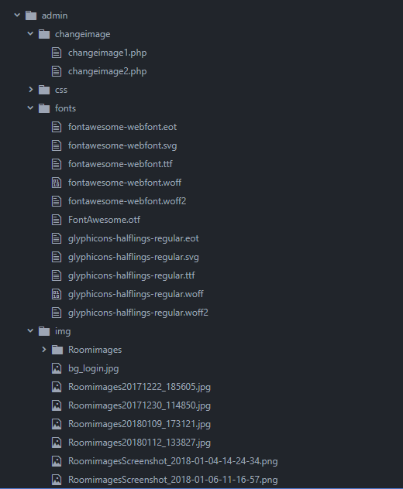

Figure Tree view of admin 1

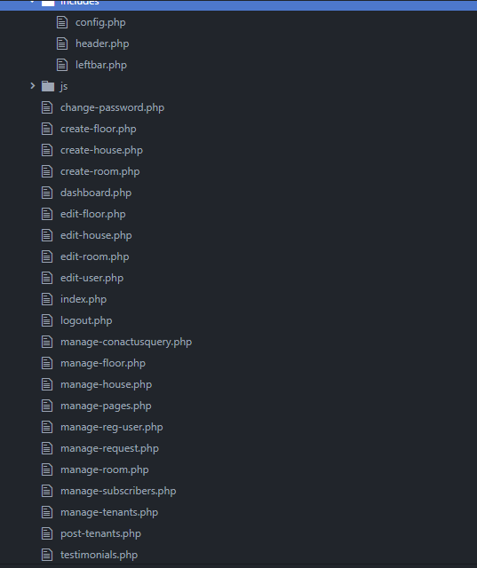

Figure Tree View of admin

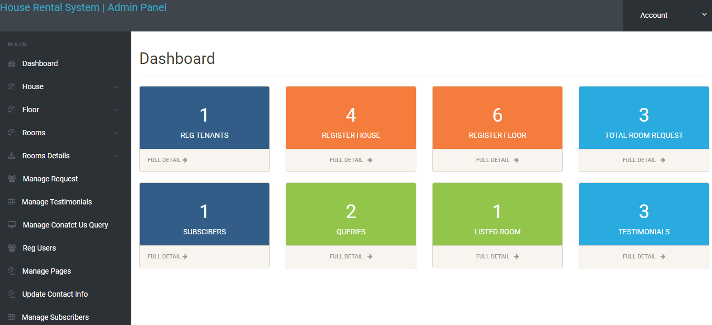

Figure Admin Dashboard

Config.php

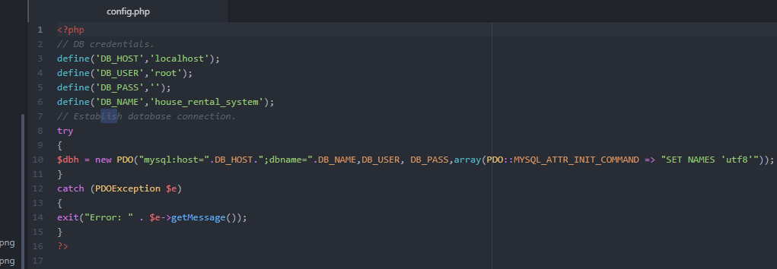

Figure Database connection

Header.php

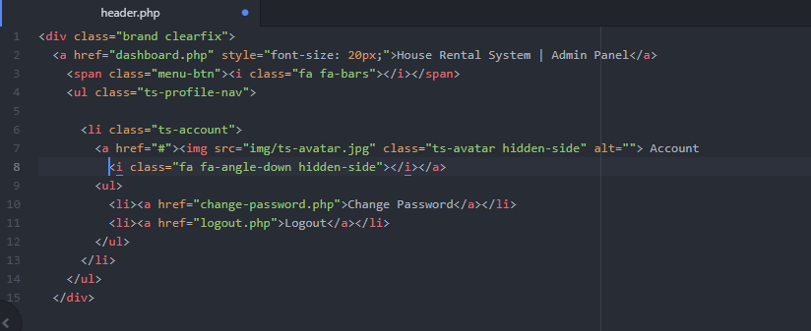

Figure Header

Leftbar.php

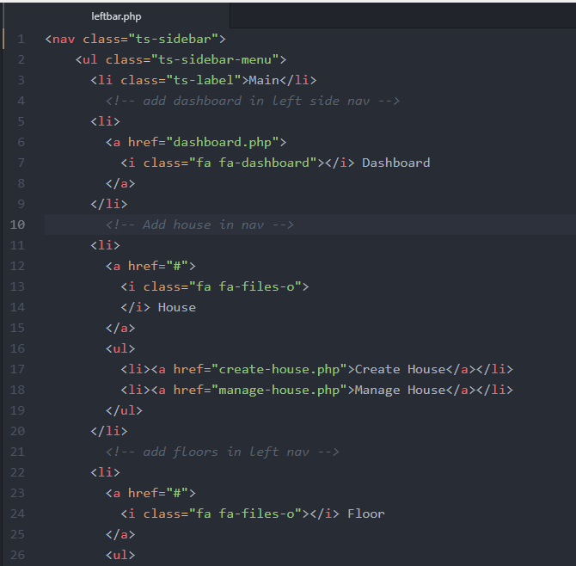

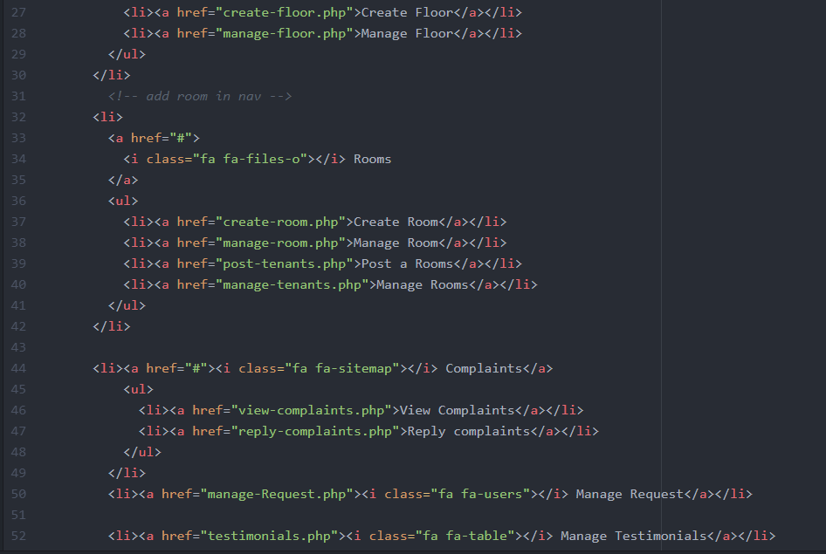

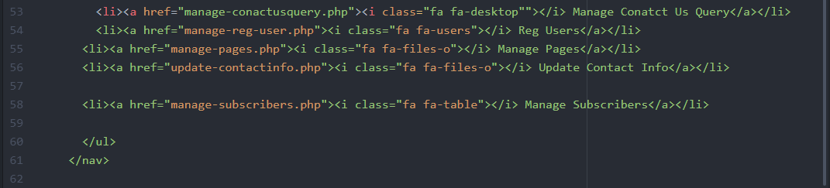

Loading Scripts code or link

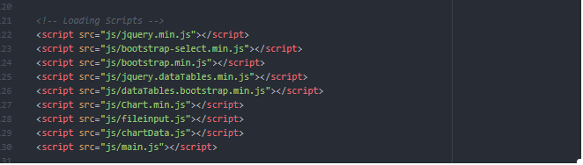

Code of inside < head> to </head> in all admin php file

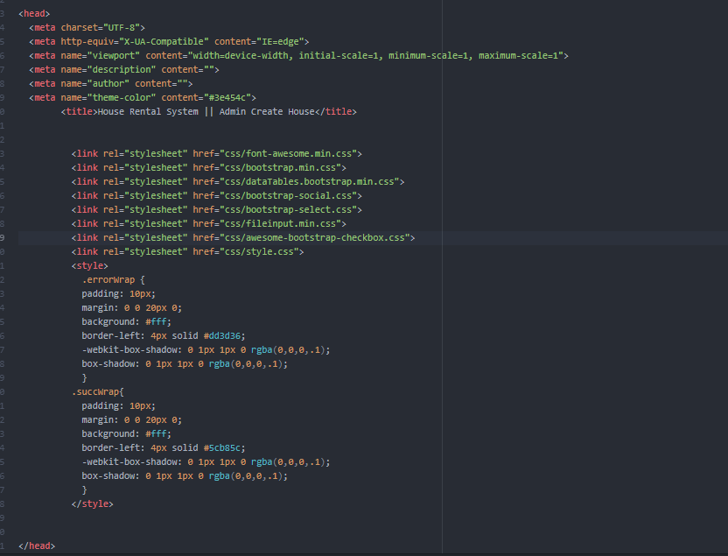

JavaScript

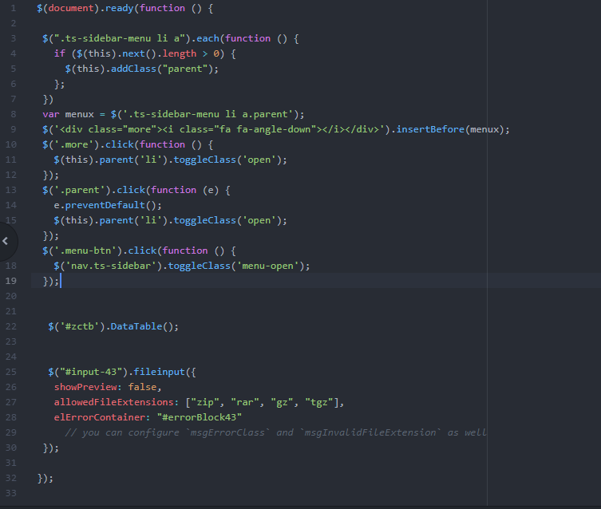

Changepassword.php

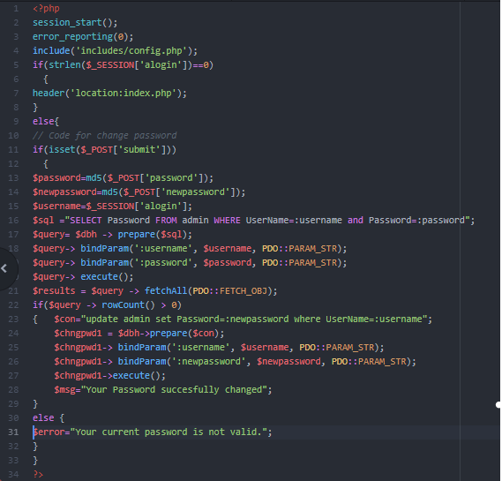

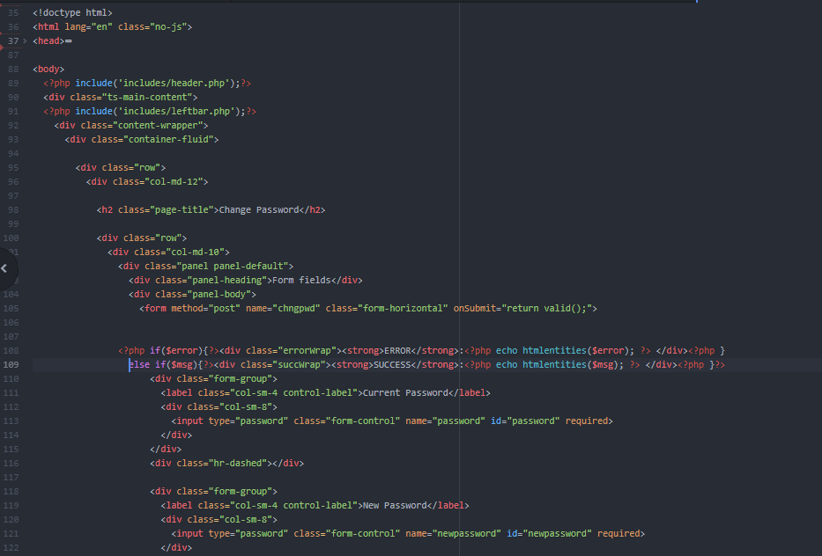

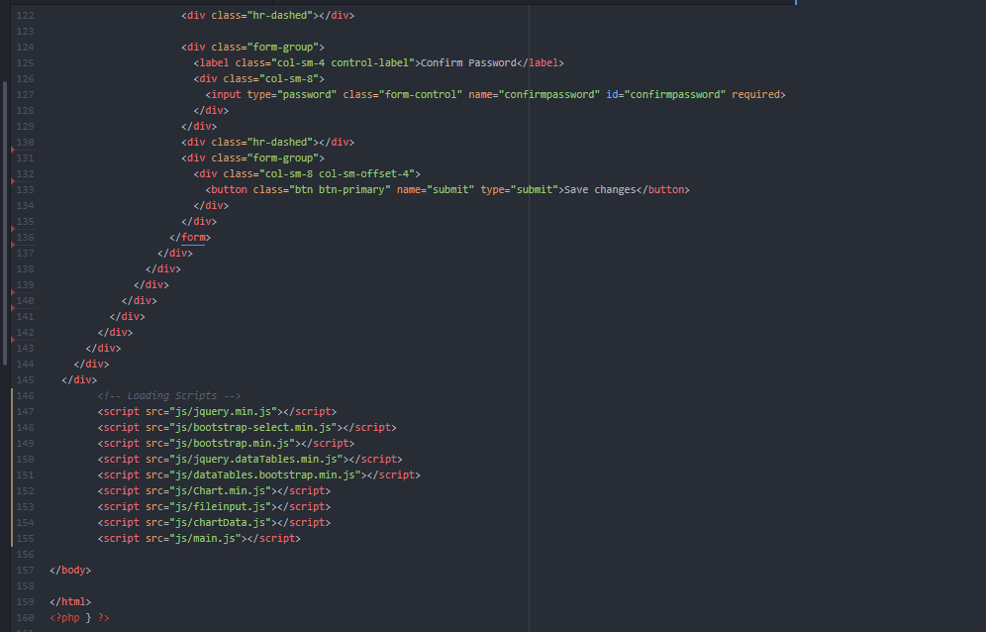

Create house or floor

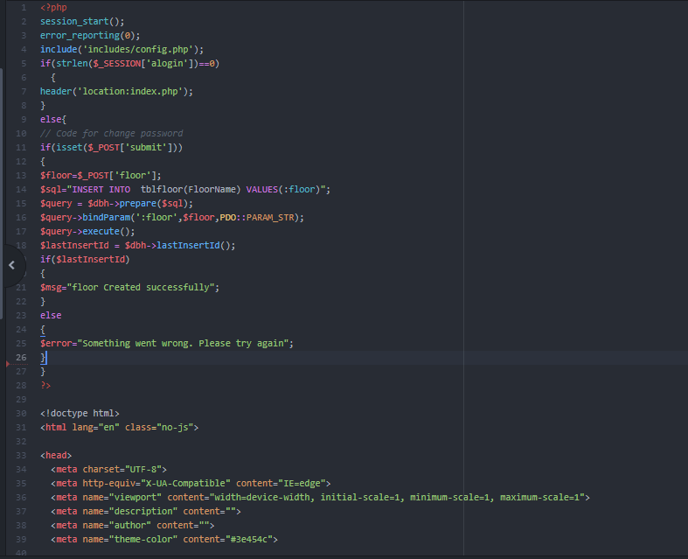

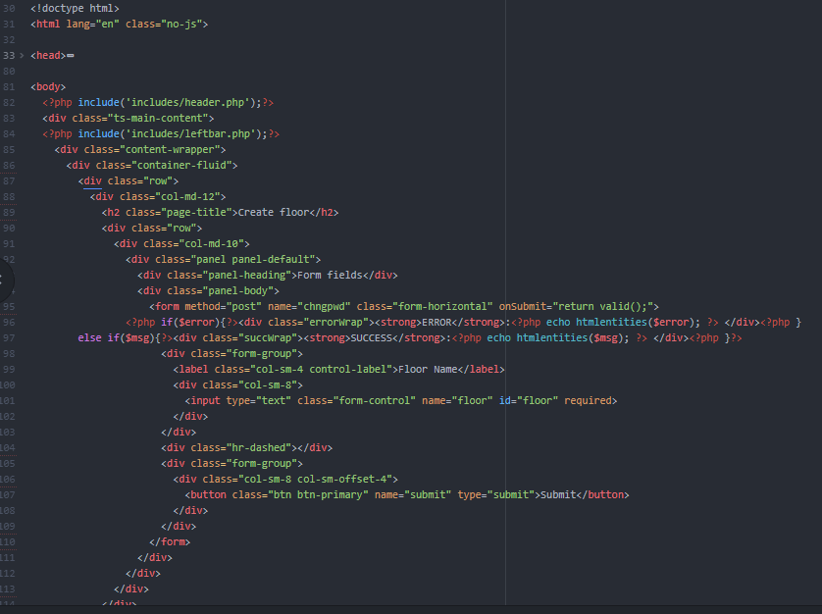

Edit house/room

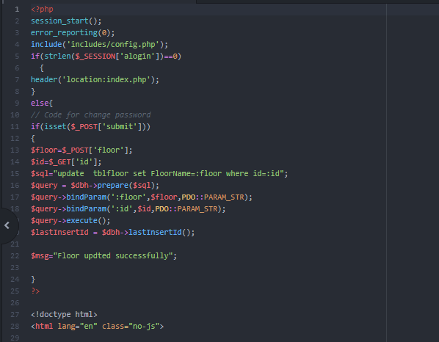

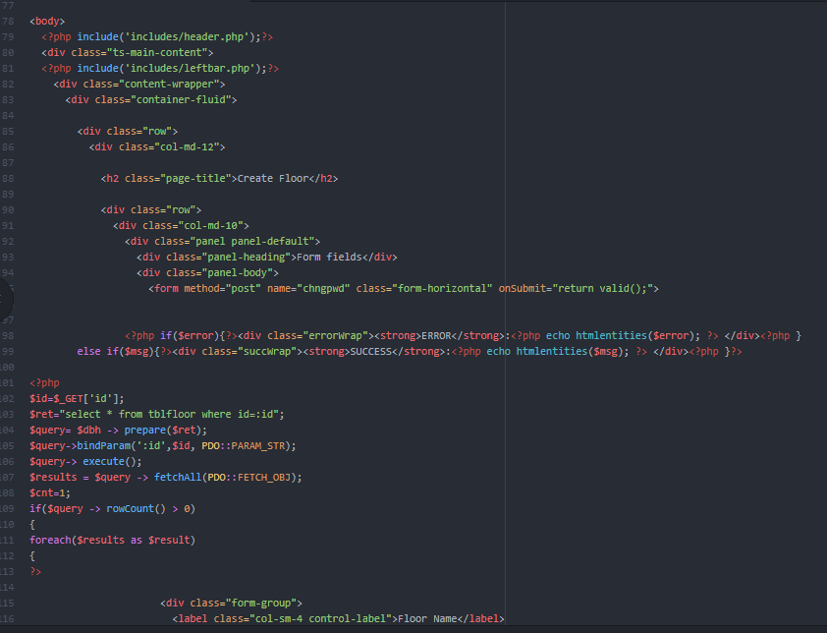

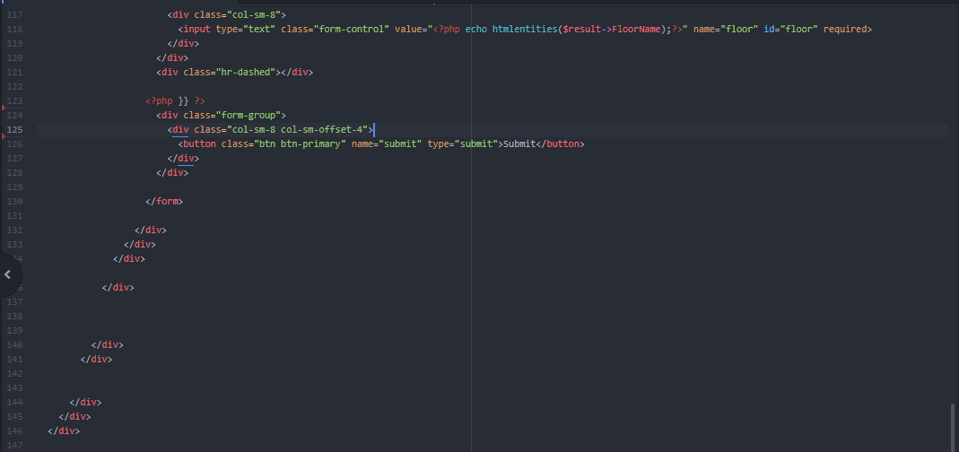

Index.php

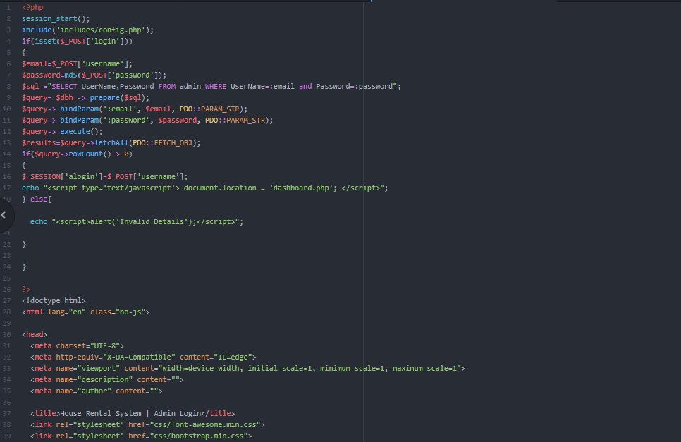

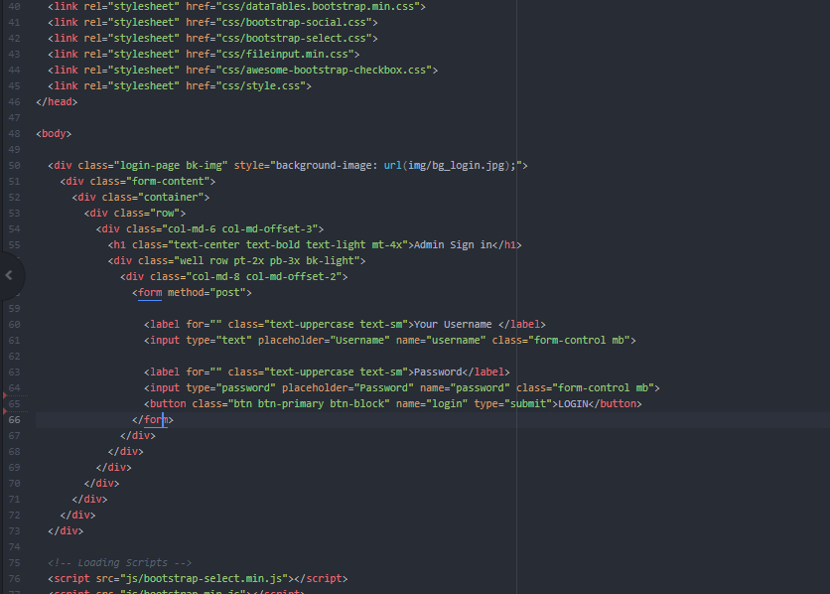

Logout.php

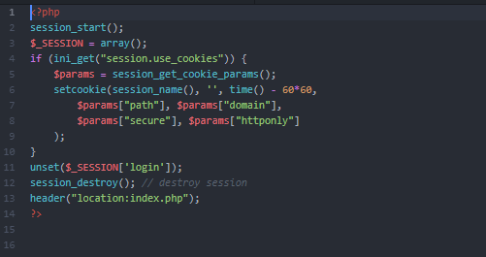

Figure logout.php

#### **USER PANEL CODE**

Code of inside <head></head>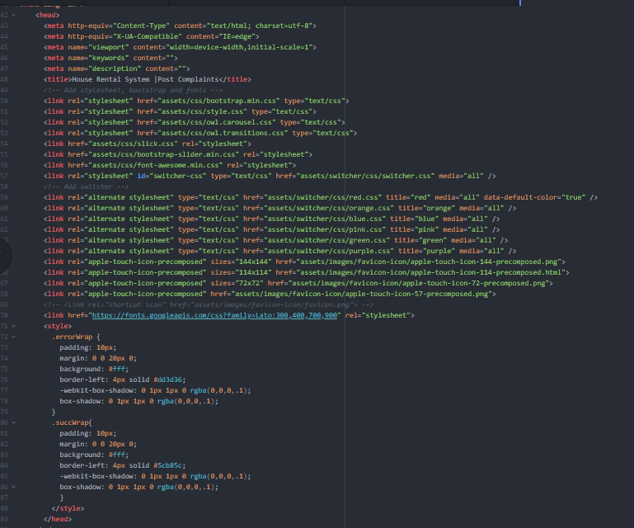

Footer and Script link

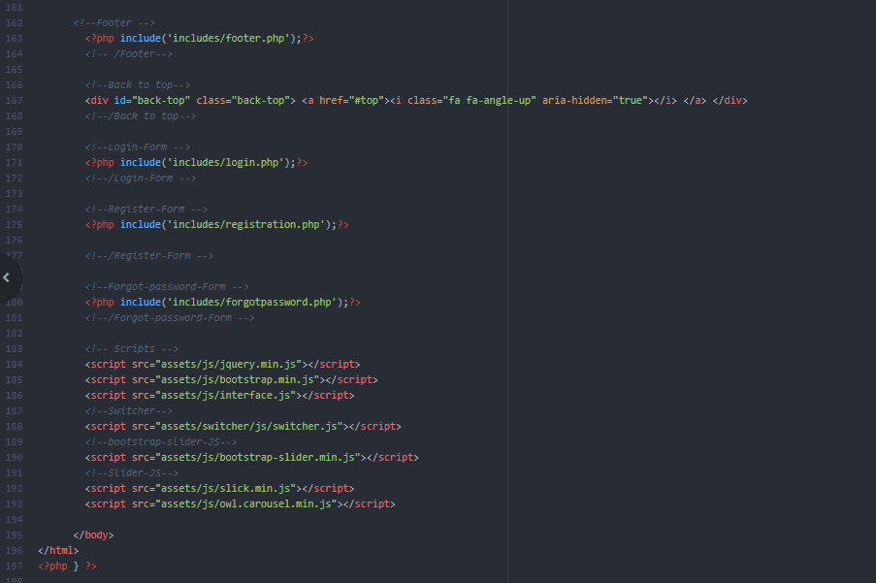

Figure user panel footer and script link

Contactus.php

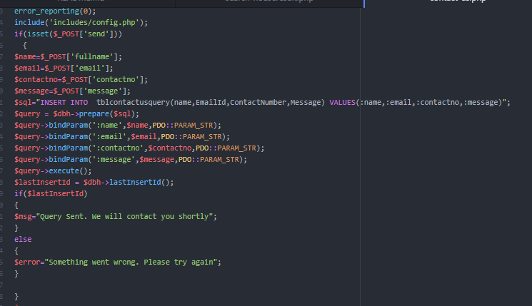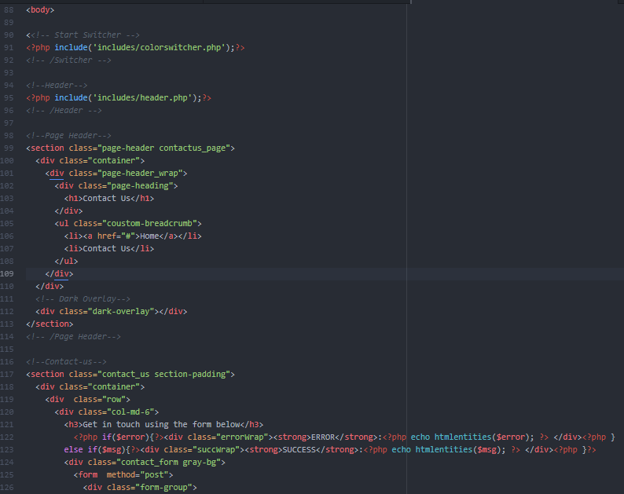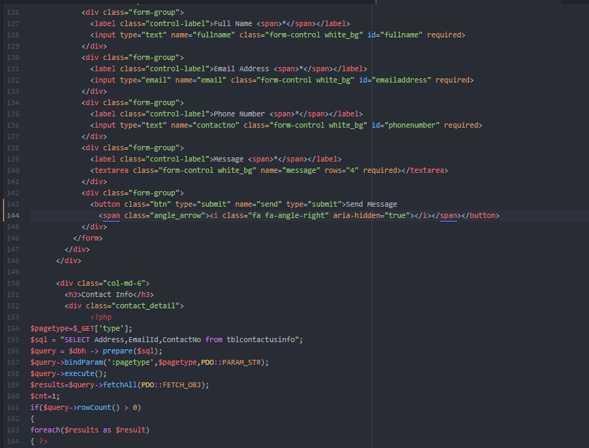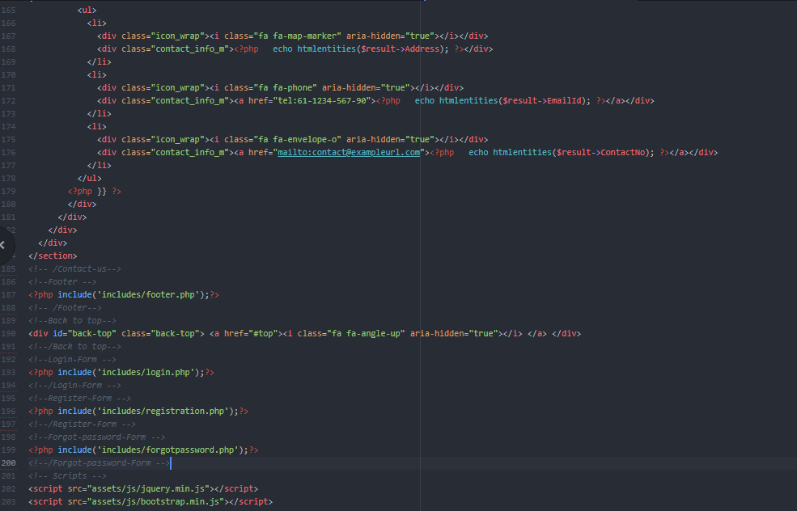

Complaint.php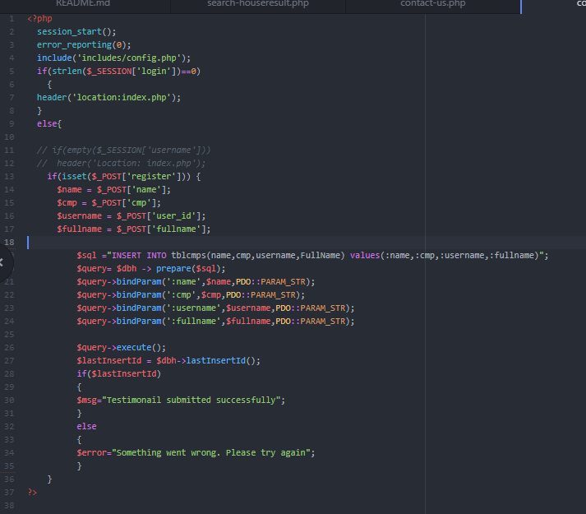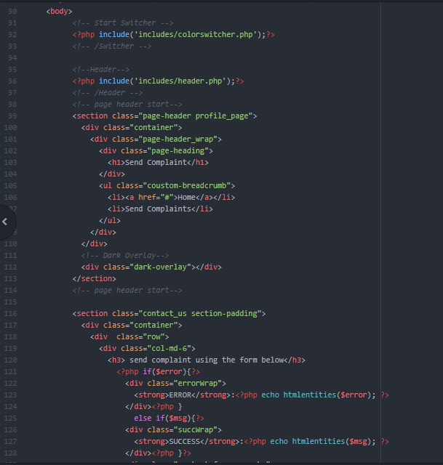

Figure Complaints page code